1. Introduction

E-testing systems are widely adopted in academic environments, as well as in combination with other assessment means, providing tutors with powerful tools to submit different types of tests in order to assess learners’ knowledge. Among these, multiple- choice tests are extremely popular, since they can be automatically corrected. However, many learners do not welcome this type of test, because often, it does not let them properly express their capacity, due to the characteristics of multiple-choice questions of being closed-ended. Even many examiners doubt about the real effectiveness of structured tests in assessing learners’ knowledge, and they wonder whether learners are more conditioned by the question type than by its actual difficulty.
In this project, we propose a data exploration approach exploiting information visualization in order to involve tutors in a visual data mining process aiming to detect structures, patterns, and relations between data, which can potentially reveal previously unknown knowledge inherent in tests, such as the test strategies used by the learners, correlations among different questions, and many other aspects, including their impact on the final score .It captures the occurrence of question browsing and answering events by the learners and uses these data to visualize charts containing a chronological review of tests. Other than identifying the most frequently employed strategies, the tutor can determine their effectiveness by correlating their use with the final test scores.

1.1 Existing system

In the existing system, several experiments have been carried out to track learners’ behavior during tests by using the think-out-loud method in which learners were informed of the experiment and had to speak during the test to explain what they were thinking, while an operator was storing their words using a tape recorder.

Disadvantages of existing system

- This technique is quite invasive, since it requires learners to modify their behavior in order to record the information to analyze.
- Complexity of identifying learners’ performance.
- Lack of identifying learners behaviors.

1.2 Proposed System

In the proposed system, we propose a data exploration approach exploiting information visualization. In the proposed system, we present a solution enabling the recording of learner’s habits during online tests without informing learners of the underlying experiment and consequently, without asking them to modify their behavior during tests, this potentially yields more realistic results.
The main goal is to extract the behavioral patterns of the learners and assessing the performance of learner and quality of test. We use data visualization technique to present the results in the form of Pie-charts, Histograms, Bar graphs etc.

Advantages of proposed system

- Presents the clear view of Learners performance using Data Visualization.
- It yields Realistic Results.
- Recording of learners habits during online tests without informing them of the underlying experiment.

3.1 Information Visualization For Knowledge

One of the main approaches for knowledge extraction is data mining, which applies automatic algorithms to recognize patterns in huge data collections. Alternatively, visual data mining presents data in a visual form to stimulate user interaction in the pattern detection process. A combination of visual and automatic data mining draws together human cognitive skills and computer efficiency, which permits faster and more efficient KDD.

Regarding the exploration of the collected data, several KDD techniques could be used. Classical data mining algorithms aim to automatically recognize patterns in the data in order to convey knowledge. However, classical data mining algorithms become inappropriate in several situations such as in multidimensional data and data not uniformly distributed. One way to overcome these problems is to use proper visual representations of data in order to stimulate user involvement in the mining process. In particular, information visualization can potentially enhance the human capability to detect structures, patterns, and relationships between data elements while exploring data. Information visualization is defined as the use of interactive visual representation of abstract data to amplify cognition.

In the past, information visualization has been successfully used in an e-learning application to measure the participation of the learners to online activities. In this, we propose a data exploration approach exploiting information visualization in order to involve tutors in a visual data mining process aiming to detect structures, patterns, and relations between data, which can potentially reveal previously unknown knowledge inherent in tests, such as the test strategies used by the learners, correlations among different questions, and many other aspects, including their impact on the final score.

3.1.1 Data Visualization

Data visualization provides a graphical representation of data, documents, and structures, which turns out to be useful for various purposes. Data visualization provides an overview of complex and large data sets, shows a summary of the data, and helps humans in the identification of possible patterns and structures in the data. Thus, the goal of data visualization is to simplify the representation of a given data set, minimizing the loss of information.
- Visualization is the graphical presentation of information, with the goal of providing the viewer with a qualitative understanding of the information contents.
- Information may be data, processes, relations, or concepts.
- Graphical presentation may entail manipulation of graphical entities (points, lines, shapes, images, text) and attributes (color, size, position, shape).
- Understanding may involve detection, measurement, and comparison, and is enhanced via interactive techniques and providing the information from multiple views and with multiple techniques.
Visualization methods can be either geometric or symbolic. In a geometric visualization, data are represented by using lines, surfaces, or volumes and are usually obtained from a physical model or as a result of a simulation or a generic computation. Symbolic visualization represents non-numeric data using pixels, icons, arrays, or graph.
It constructs a 3D visualization space by classifying the visualization methods according to three orthogonal criteria, the data type, the type of the visualization technique, and the interaction methods.
The 2D/3D displays are line graphs and iso-surfaces, histograms, kernel plots, box-and-whiskers plots, scatter plots, contour plots, and pie charts The scatter plot matrix, the permutation matrix, and its closely related survey plot are all examples of geometrically transformed visualization methods.

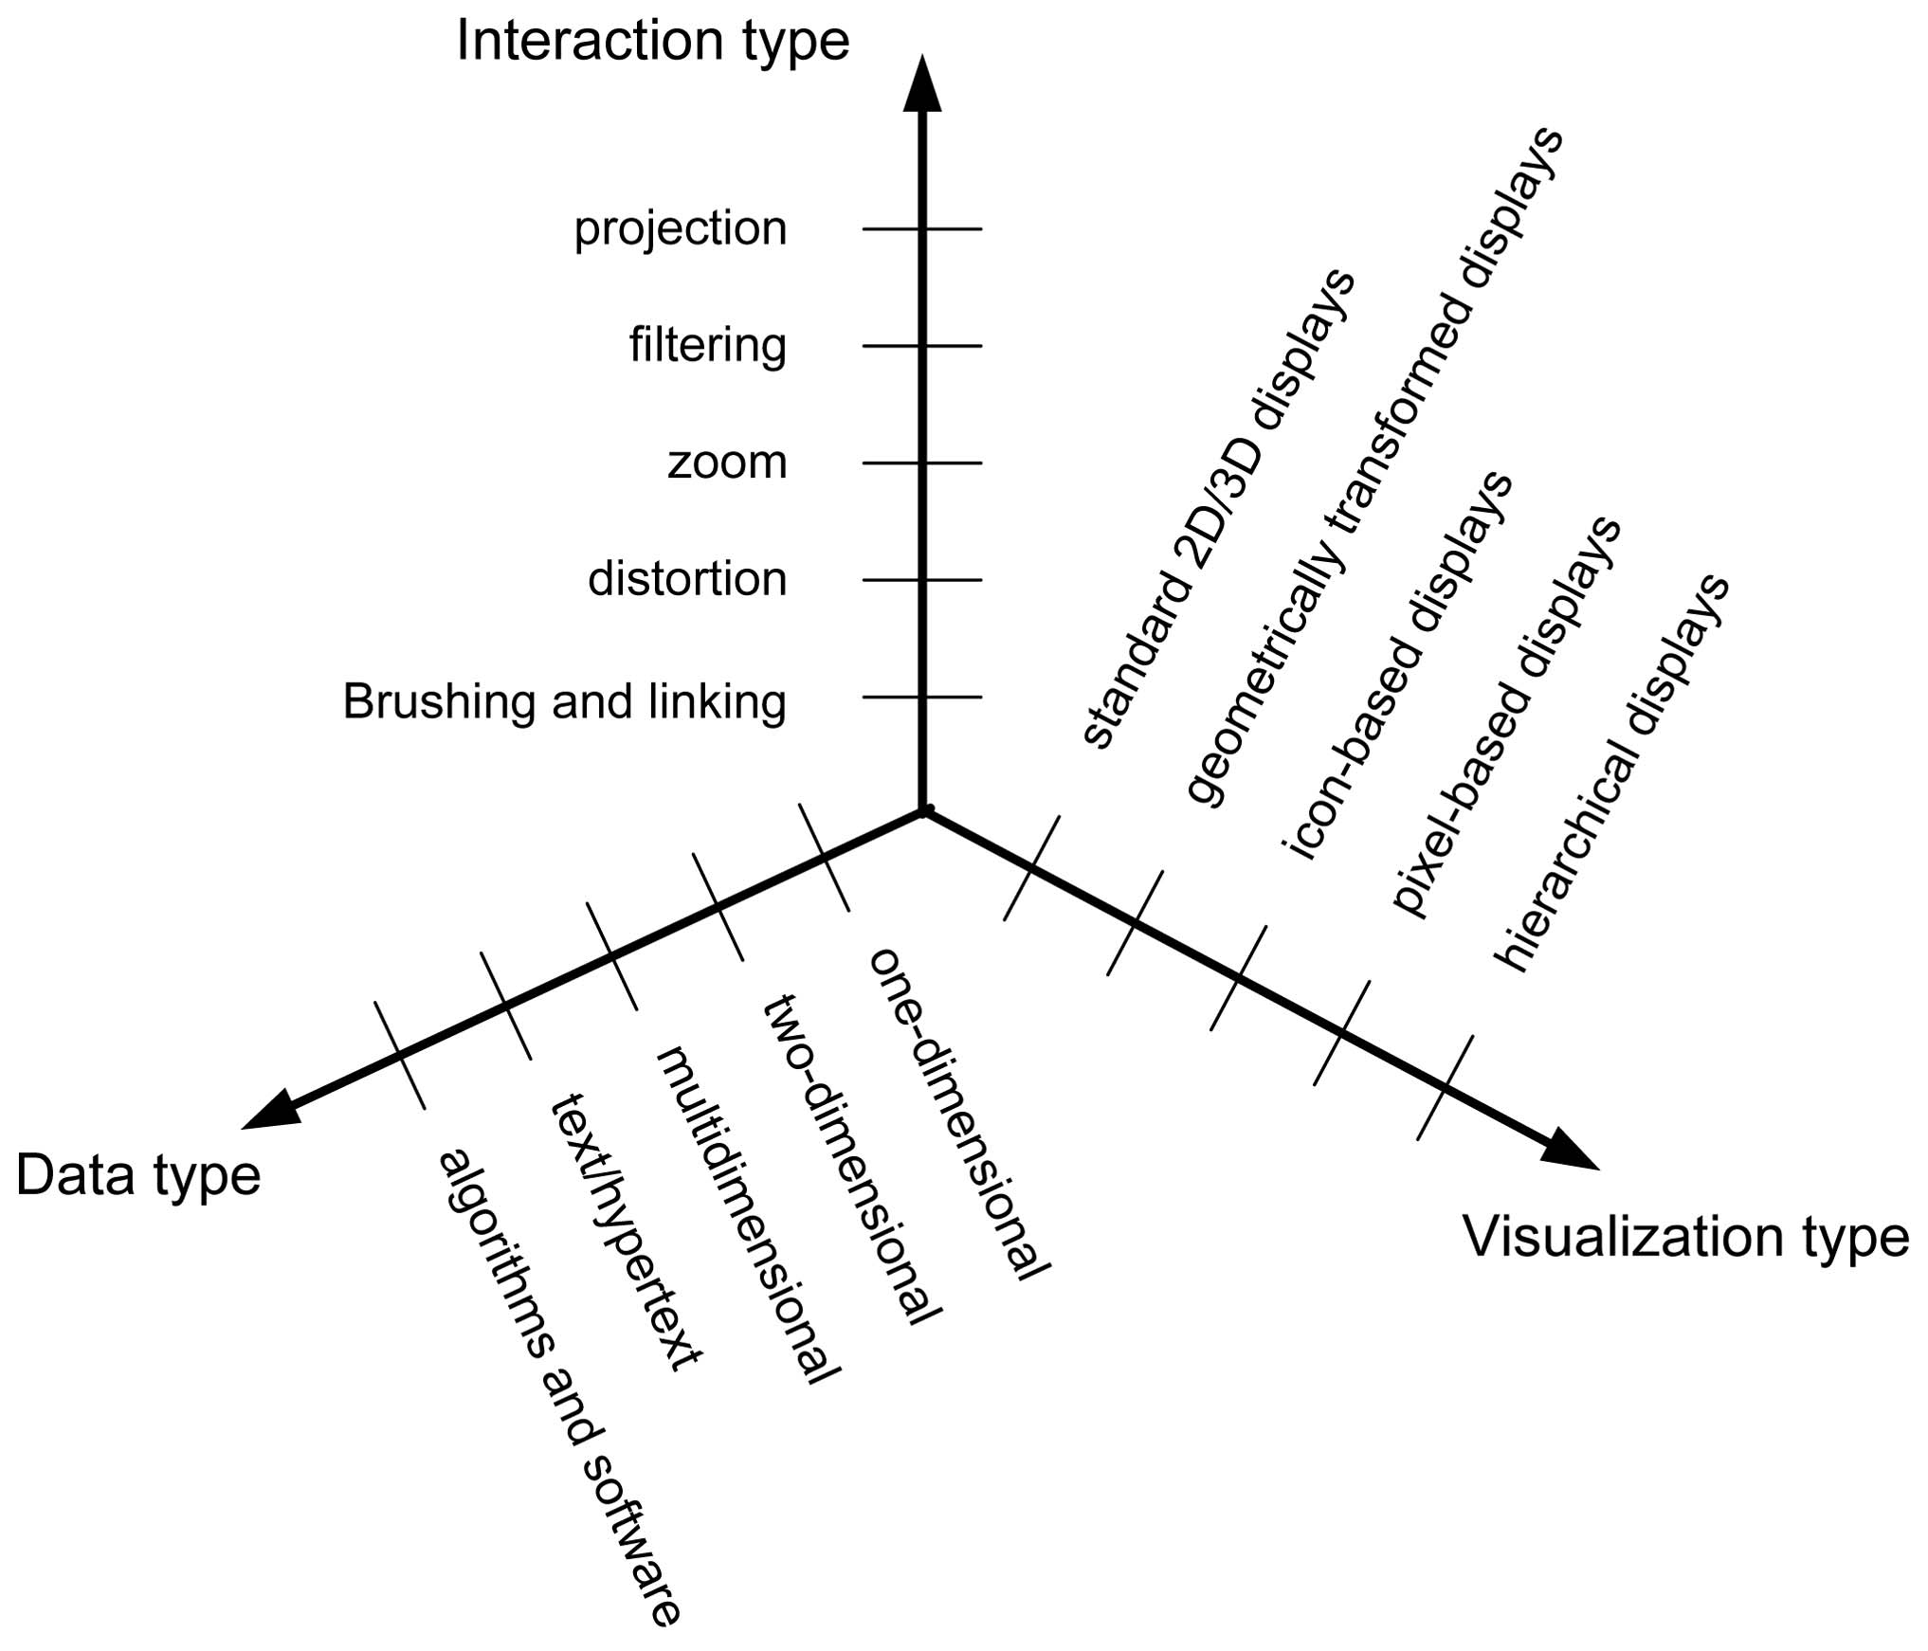

Fig 3.1 Three-Dimensional Visualization space

Presentation of good data visualization

The following are the qualities which satisfy for a good data visualization presentation.
- Effective

Due to this quality, the viewer gets information at a single glance. It provides ease of interpretation
- Accurate

Accuracy is sufficient for correct quantitative evaluation.
- Efficient

Minimize data presentations and summaries are present in a single view.
- Aesthetics
Must not offend viewer's senses. For example more patterns.
- Adaptable
Can adjust to serve multiple needs
3.1.2 Visual Data Mining

The process of visual data mining can be seen as a hypothesis-generating process. The user generates a hypothesis about relationships and patterns in the data. Visual data mining has several advantages over the automatic data mining methods. It leads to a faster result with a higher degree of human confidence in the findings, because it is intuitive and requires less understanding of complex mathematical and computational background than automatic data mining.
It is effective when little is known about the data and the exploration goals are vague, since these can be adjusted during the exploration process. Visual mining can provide a qualitative overview of the data and allow unexpectedly detected phenomena to be pointed out and explored using further quantitative analysis.
The visual data mining process starts by forming the criteria about which visualizations to choose and which attributes to display. These criteria are formulated according to the exploration task. The user recognizes patterns in open visualizations and selects a subset of items s/he is interested in. The result of this selection is a restriction of the search space, which may show new patterns to the user, some of which s/he might not have been aware of before.
The whole process can then be repeated on the selected subset of data items. Alternatively, new visualizations can be added. The process continues until the user is satisfied with the result, which represents a solution to her/his initial problem. The user has full control over the exploration by interacting with the visualizations.
Visual data mining has been used in a number of scientific disciplines. Some recent examples include detecting telephone call frauds by a combination of directed graph drawings and barplots, a classifier based on a parallel coordinate plot, and a visual mining approach by applying 3D parallel histograms to temporal medical data.

3.2 Knowledge Discovery
Knowledge discovery is a concept of the field of computer science that describes the process of automatically searching large volumes of data for patterns that can be considered knowledge about the data .It is often described as deriving knowledge from the input data. This complex topic can be categorized according to what kind of data is searched and in what form is the result of the search represented. Knowledge discovery developed out of the Data mining domain, and is closely related to it both in terms of methodology and terminology.
The most well-known branch of data mining is knowledge discovery, also known as Knowledge Discovery in Databases (KDD). Just as many other forms of knowledge discovery it creates abstractions of the input data. The knowledge obtained through the process may become additional data that can be used for further usage and discovery. Another promising application of knowledge discovery is in the area of software modernization which involves understanding existing software artifacts. This process is related to a concept of reverse engineering. Usually the knowledge obtained from existing software is presented in the form of models to which specific queries can be made when necessary. An entity relationship is a frequent format of representing knowledge obtained from existing software.
Object Management Group (OMG) developed specification Knowledge Discovery Metamodel (KDM) which defines an ontology for the software assets and their relationships for the purpose of performing knowledge discovery of existing code. Knowledge discovery from existing software systems, also known as software mining is closely related to data mining. Instead of mining individual data sets, software mining focuses on metadata, such as database schemas.
Knowledge Discovery in Data is non-trivial process of identifying
- valid
- novel
- potentially useful and
- Ultimately understandable patterns in data.

Visualization
Machine
Learning

Data Mining and
Knowledge Discovery

Databases
Statistics

Fig 3.2 Knowledge discovery presentation
3.1 TECHNICAL FEASIBILITY:
Evaluating the technical feasibility is the trickiest part of a feasibility study. This is because, at this point in time, not too many detailed design of the system, making it difficult to access issues like performance, costs on (on account of the kind of technology to be deployed) etc. A number of issues have to be considered while doing a technical analysis.
- Understand the different technologies involved in the proposed system:
Before commencing the project, we have to be very clear about what are the technologies that are to be required for the development of the new system.
- Find out whether the organization currently possesses the required technologies:
  - Is the required technology available with the organization?
  - If so is the capacity sufficient?
For instance –
“Will the current vizuvalization Api to handle the new Visuval Charts Like 2D and 3D ”
3.2 OPERATIONAL FEASIBILITY:
Proposed projects are beneficial only if they can be turned into information systems that will meet the organizations operating requirements. Simply stated, this test of feasibility asks if the system will work when it is developed and installed. Are there major barriers to Implementation? Here are questions that will help test the operational feasibility of a project:
- Is there sufficient support for the project from management from users? If the current system is well liked and used to the extent that persons will not be able to see reasons for change, there may be resistance.
- Are the current business methods acceptable to the user? If they are not, Users may welcome a change that will bring about a more operational and useful systems.
- Have the user been involved in the planning and development of the project?
- Early involvement reduces the chances of resistance to the system and in
- General and increases the likelihood of successful project.
Since the proposed system was to help reduce the hardships encountered. In the existing manual system, the new system was considered to be operational feasible.

3.3 ECONOMICAL FEASIBILITY:
Economic feasibility attempts 2 weigh the costs of developing and implementing a new system, against the benefits that would accrue from having the new system in place. This feasibility study gives the top management the economic justification for the new system.
A simple economic analysis which gives the actual comparison of costs and benefits are much more meaningful in this case. In addition, this proves to be a useful point of reference to compare actual costs as the project progresses. There could be various types of intangible benefits on account of automation. These could include increased customer satisfaction, improvement in product quality better decision making timeliness of information, expediting activities, improved accuracy of operations, better documentation and record keeping, faster retrieval of information, better employee morale.

4.1 System Requirements And Specifications
4.1.1 Purpose of the System
This system provides the behavioral pattern of the learners in the visualization format where the tutors can assess the learners performance as when they execute the online test.This makes the tutors to know about the actual capabilities of the learners and improve their knowledge based on the performance obtained.

4.1.2 Scope of the System
Visualization is the Mining Technique used in this project in order to show Behavioral patterns of the the learners conducted by Tutor to improve the whole assessment process.
Visualization Consist of Two Main Phases:

- Tutor
Here main functionality is to Monitor behavioral patterns of learners while attempting online test. Tutors monitor several important aspects related to online tests, such as learner behavior and test quality during the execution of online tests and exploits data visualization to highlight information useful to let tutors review and improve the whole assessment process.

- Learner
Learners Are Motivated by Tutor inorder to improve learners skills and whole assessment process.

4.1.3 Functional requirements

- It should provide the Tutor to generate data visualization charts dynamically it shows Learners Behavioral Patterns.

- It Provides Tutor to Monitor Important aspects of Online Tests like Behavioral Pattern and Test Quality.

- It Provides Tutors to Motivate the Learners in order to improve their skills based on behavioral patterns.

- It would let tutors exploit many currently available data exploration and knowledge discovery strategies to elicit important insights on the testing activities that can be used to teach learners how to improve their performances.

- It Provides data exploration approach exploiting information visualization in order to involve tutors in a visual data mining process aiming to detect structures, patterns, and relations between data, which can potentially reveal previously unknown knowledge inherent in tests, such as the test strategies used by the learners, correlations among different questions, and many other aspects, including their impact on the final score.

4.1.4 Non-Functional Requirements

Performance
- Extracting Behavioral Patterns and showing them through visuvalization technique
- JFreechart is the third Party API used to maintain Data Visualization Techniques.
Supportability
- The system is designed to be the cross platform supportable. The system is supported on a wide range of hardware and any software platform which is having JVM built into the system.
- This application is being developed using J2EE; hence it is extremely portable.

Usability
- The system is designed with good user interface so as to provide the tutors with the ability to generate graphs from data and adjust the graph parameters dynamically.

Implementation
- The system is implemented in web environment. The apache tomcat is used as the web server and windows Xp professional is used as the platform and oracle10g as backend.

Reliability
- The system is more reliable because of the qualities that are inherited from the chosen platform java. The code built by using java is more reliable.
4.3 SDLC METHDOLOGIES

This document play a vital role in the development of life cycle (SDLC) as it describes the complete requirement of the system. It means for use by developers and will be the basic during testing phase. Any changes made to the requirements in the future will have to go through formal change approval process.

SPIRAL MODEL was defined by Barry Boehm in his 1988 article, “A spiral Model of Software Development and Enhancement. This model was not the first model to discuss iterative development, but it was the first model to explain why the iteration models.

As originally envisioned, the iterations were typically 6 months to 2 years long. Each phase starts with a design goal and ends with a client reviewing the progress thus far. Analysis and engineering efforts are applied at each phase of the project, with an eye toward the end goal of the project.

The steps for Spiral Model can be generalized as follows:

- The new system requirements are defined in as much details as possible. This usually involves interviewing a number of users representing all the external or internal users and other aspects of the existing system.
- A preliminary design is created for the new system.
- A first prototype of the new system is constructed from the preliminary design. This is usually a scaled-down system, and represents an approximation of the characteristics of the final product.
- A second prototype is evolved by a fourfold procedure:
- Evaluating the first prototype in terms of its strengths and risks.
- Defining the requirements of the second prototype.
- Planning an designing the second prototype.
- Constructing and testing the second prototype.
- At the customer option, the entire project can be aborted if the risk is deemed too great. Risk factors might involve development cost overruns, operating-cost miscalculation, or any other factor that could, in the customer’s judgment, result in a less-than-satisfactory final product.
- The existing prototype is evaluated in the same manner as was the previous prototype, and if necessary, another prototype is developed from it according to the fourfold procedure outlined above.
- The preceding steps are iterated until the customer is satisfied that the refined prototype represents the final product desired.
- The final system is constructed, based on the refined prototype.
- The final system is thoroughly evaluated and tested. Routine maintenance is carried on a continuing basis to prevent large scale failures and to minimize down time.
he following diagram shows how a spiral model acts like:
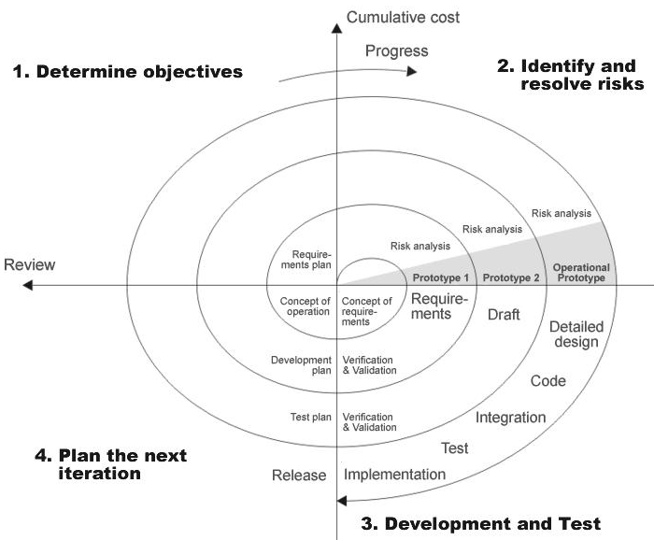

Fig 1.0-Spiral Model

ADVANTAGES

- Estimates(i.e. budget, schedule etc .) become more relistic as work progresses, because important issues discoved earlier.
- It is more able to cope with the changes that are software development generally entails.
- Software engineers can get their hands in and start woring on the core of a project earlier.

- We are providing interactive data visualizing techniques to observe the Patterns and to adjust the graph parameters dynamically. So we can say that this system is reliable.

Interface
- The user interface is based on the web browser. The application is developed using JSP and HTML along with DHTML.
- The Interface design is aimed at a flexible front-end communication to provide the user with clear information in navigating a user-friendly interface is planned.

4.2 Data Visualization API
JFreeChart is an open-source framework for the programming language Java, which allows the creation of complex charts in a simple way. David Gilbert founded the JFreeChart project in February 2000. Now a days, it is used by around 40000 to 50000 developers. It is used to generate the charts like Area and Line Charts, Pie charts, Bar Charts, Bubble Charts, Gantt Charts. Apart charts, it is possible to place various markers on the plot.JFreeChart automatically draws the axis scales and legends.Charts in GUI automatically get the capability to zoom in with mouse and change some settings through local menu. The existing charts can be easily updated through the listeners that the library has on its data collections. Developers get a better choice to add professional quality charts in swing and web based application by JFree Chart. JFree Chart provides many interactive features like tooltips.

JFreeChart includes some of the following features :
- JFreeChart have well documented API, which supports the wide range of charts.
- JFreeChart supports Swing components, vector graphics file format and image files.
- JFreeChart is easy to extend and it can be used for developing client side and server side applications.

.JCommon
JFreeChart requires the JCommon class library .It is a collection of useful classes that is used by JFreeChart project. The JCommon library has common classes that provide some global utility functionality for non-GUI and GUI applications.

Some of the following features available in JCommon library are
- a general logging framework
- user interface classes for displaying information about applications
- configuration and dependency management code
- text utilities
- custom layout managers
- serialization utilities
- XML parser support classes

Type Of Visualization Techniques Through JfreeChart
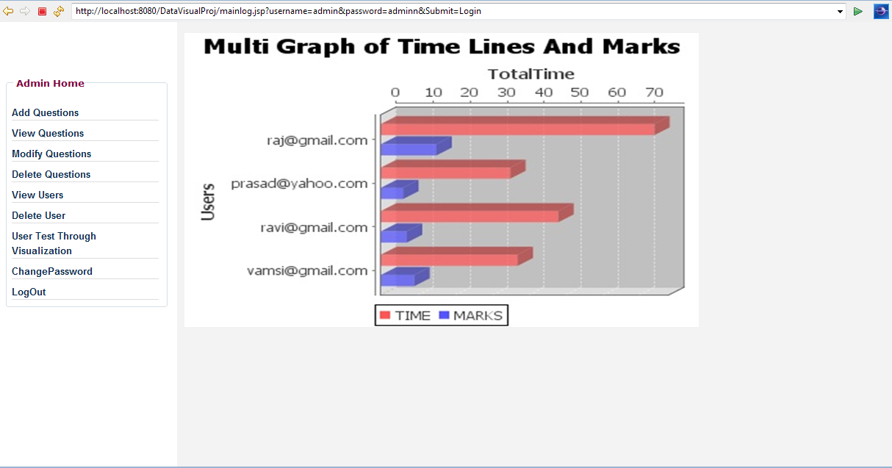
Fig 4.1 Example of Data Visualization

4.3 Modules
- Admin
- Users

4.3.1 Admin
The main functionality of Admin is deriving Behavioral Patterns of the users and
monitoring those patterns through visualization Technique. The sub modules of Admin are

- Add Questions
Here Admin can perform adding questions of various subjects like c, c++, java, oracle etc.
- Subject Selection
Here Admin can choose various subjects to add questions for E-Testing system for Learners.
- Modify Questions
Here Admin can modify the questions as well as answers of various subjects.
- Delete Questions
To maintain test quality Admin has a facility to delete the questions of various subjects.
- Monitor Users Through Data Visualization Technique
Here Admin is monitoring the users Behavioral Patterns through visualization technique
Behavioral Patterns Monitored By Admin
  - Type of questions performed by users.
  - Time taken for each question while attempting the exam.
  - How many times the users change the options in each question.
  - Total time taken for E-Testing completion.

- Change Password
Admin can change the password .
- Logout
- Here Admin is navigated to Homepage.
4.3.2 User
Here user has a register to attempt E-Testing system. The submodules of the user are
- Login
User should Login to perform the E-Testing system.
- Register
User should submit details while registration time.
- Subject Selection
Before going to E-Testing system page user should select any subjects like java, c, c++, oracle etc.
- Attempting E-Testing System
User should attempt the E-Testing system. Here users’ Behavioral Patterns are captured and those are stored in Database for future use.
- Logout
Here user is navigated to Homepage.

5. System Design

Design is the first step in the development phase of any principle or technique, for the purpose of defining a device, a process or system in sufficient detail to permit its physical realization. Once the software requirements have been analyzed and specified, the software design involves three technical activities-Design, Coding, Generation and Testing that are required to build and verify the software

5.1 Overview of UML
Unified Modeling Language (UML) is a standardized general-purpose modeling language .in the field of software engineering. UML includes a set of graphical notation techniques to create abstract models of specific systems.
UML combines the best practice from data modeling concepts such as entity relationship diagrams, business modeling (work flow), object modeling and component modeling. It can be used with all processes, throughout the software development life cycle, and across different implementation technologies. UML has succeeded the concepts of the Booch method, the Object-modeling technique (OMT) and Object-oriented software engineering (OOSE) by fusing them into a single, common and widely usable modeling language. UML aims to be a standard modeling language which can model concurrent and distributed systems. UML is not an industry standard, but is taking shape under the auspices of the Object Management Group (OMG). OMG has initially called for information on object-oriented methodologies that might create a rigorous software modeling language. Many industry leaders have responded in earnest to help create the standard.

5.1.1 Modeling
It is very important to distinguish between the UML model and the set of diagrams of a system. A diagram is a partial graphical representation of a system's model. The model also contains a "semantic backplane" -- documentation such as written use cases that drive the model elements and diagrams.
UML diagrams represent two different views of a system model:
- Static (or structural) view
Emphasizes the static structure of the system using objects, attributes, operations and relationships. The structural view includes class diagrams and composite structure diagrams.
- Dynamic (or behavioral) view
Emphasizes the dynamic behavior of the system by showing collaborations among objects and changes to the internal states of objects. This view includes sequence diagrams, activity diagrams and state machine diagrams.

5.1.2 Diagrams Overview
UML 2.0 has 13 types of diagrams divided into three categories. Six diagram types represent the structure application, seven represent general types of behavior including four that represent different aspects of interactions.

Structure diagrams
Structure diagrams emphasize what things must be in the system being modeled:
- Class diagram
Describes the structure of a system by showing the system's classes, their attributes, and the relationships among the classes.
- Component diagram
Depicts how a software system is split up into components and shows the dependencies among these components.
- Composite structure diagram
Describes the internal structure of a class and the collaborations that this structure makes possible.
- Deployment diagram
Serves to model the hardware used in system implementations, and the execution environments and artifacts deployed on the hardware.
- Object diagram
Shows a complete or partial view of the structure of a modeled system at a specific time.
- Package diagram
Depicts how a system is split up into logical groupings by showing the dependencies among these groupings.
Since structure diagrams represent the structure of a system, they are used extensively in documenting the architecture of software systems.

Behavior diagrams
Behavior diagrams emphasize what must happen in the system being modeled.

- Activity diagram
Represents the business and operational step-by-step workflows of components in a system. An activity diagram shows the overall flow of control.

- State machine diagram
Standardized notation to describe many systems, from computer programs to business processes.
- Use case diagram
Shows the functionality provided by a system in terms of actors, their goals represented as use cases, and any dependencies among those use cases.
Since behavior diagrams illustrate the behavior of system, they are used extensively to describe the functionality of software systems.

Interaction diagrams
Interaction diagrams, a subset of behavior diagrams, emphasize the flow of control and data among the things in the system being modeled.

- Communication diagram
Shows the interactions between objects or parts in terms of sequenced messages. They represent a combination of information taken from Class, Sequence, and Use Case Diagrams describing both the static structure and dynamic behavior of a system.
- Interaction overview diagram
are a type of activity diagram in which the nodes represent interaction diagrams.
- Sequence diagram
shows how objects communicate with each other in terms of a sequence of messages. Also indicates the lifespans of objects relative to those messages.

- Timing diagrams
These are a specific type of interaction diagram, where the focus is on timing constraints.
5.2 Relationships
A relationship is a general term covering the specific types of logical connections found on class and object diagrams. UML shows the following relationships:

External links
A Link is the basic relationship among objects. It is represented as a line connecting two or more object boxes. It can be shown on an object diagram or class diagram. A link is an instance of an association.

Association
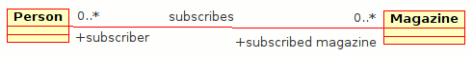
Class diagram example of association between two classes
An Association represents a family of links. Binary associations (with two ends) are normally represented as a line, with each end connected to a class box. Higher order associations can be drawn with more than two ends. In such cases, the ends are connected to a central diamond.
An association can be named, and the ends of an association can be adorned with role names, ownership indicators, multiplicity, visibility, and other properties. There are five different types of association. Bi-directional and uni-directional associations are the most common ones.
Aggregation
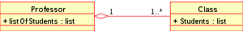
Class diagram showing Aggregation between two classes
Aggregation is a variant of the "has a" or association relationship; aggregation is more specific than association. It is an association that represents a part-whole relationship. As a type of association, an aggregation can be named and have the same adornments that an association can.
However, an aggregation may not involve more than two classes.Aggregation can occur when a class is a collection or container of other classes, but where the contained classes do not have a strong life cycle dependency on the container--essentially, if the container is destroyed, its contents are not.
In UML, it is graphically represented as a clear diamond shape on the containing class end of the tree of lines that connect contained classes to the containing class.

Composition
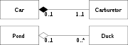
Class diagram showing Composition between two classes at top and Aggregation between two classes at bottom
Composition is a stronger variant of the "has a" or association relationship; composition is more specific than aggregation. It is represented with a solid diamond shape.
Composition usually has a strong life cycle dependency between instances of the container class and instances of the contained classes: If the container is destroyed, normally every instance that it contains is destroyed as well. Note that a part can (where allowed) be removed from a composite before the composite is deleted, and thus not be deleted as part of the composite.
The UML graphical representation of a composition relationship is a filled diamond shape on the containing class end of the tree of lines that connect contained classes to the containing class.

5.3 Use-Case diagrams

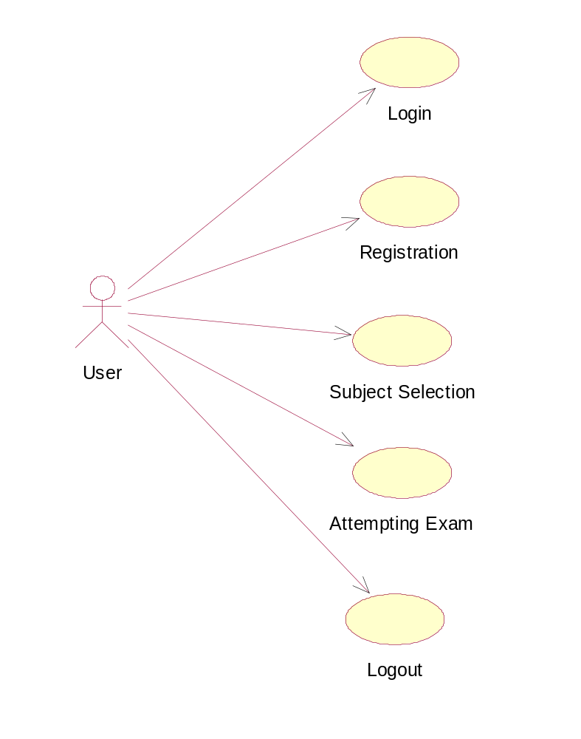

Fig 5.1 Usecase diagram for User

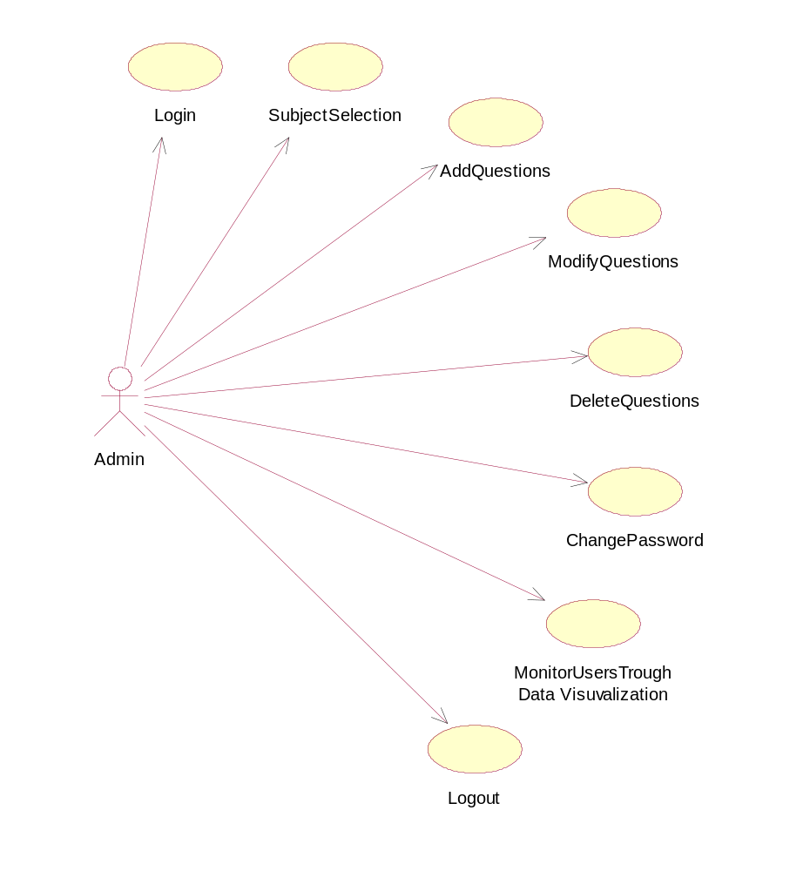
Fig 5.2 Usecase diagram for Admin

5.4 Class Diagram

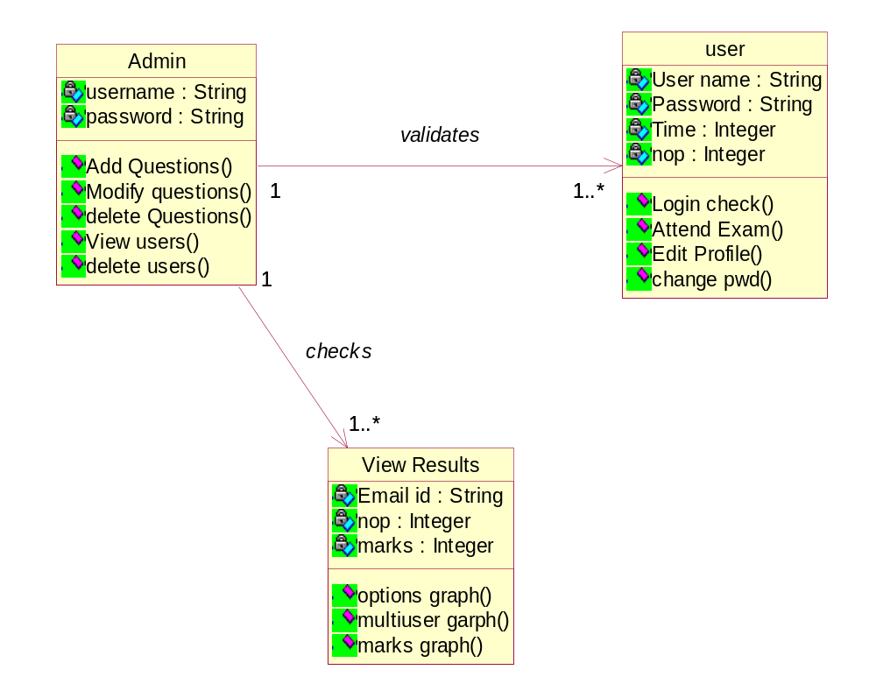

Fig 5.3 Class Diagram

5.5 Sequence Diagrams

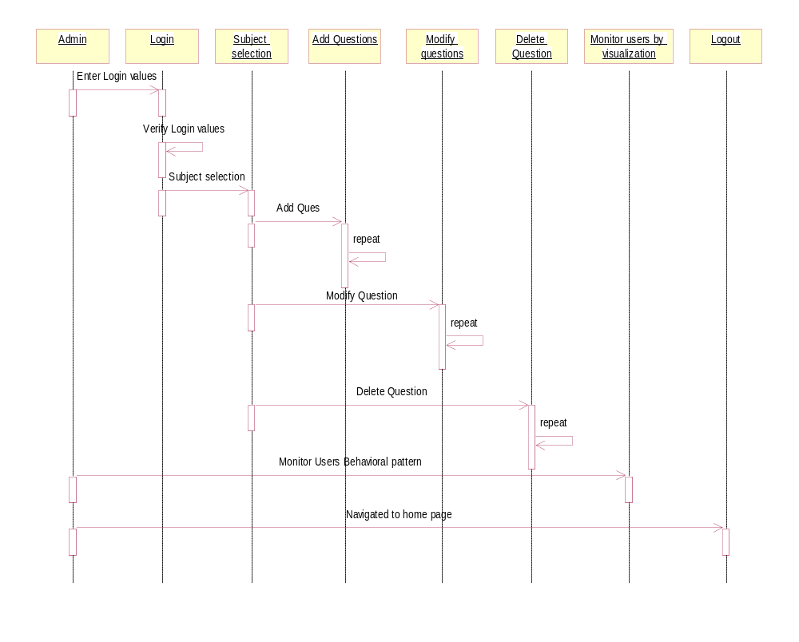

Fig 5.4 Sequence Diagram For Admin

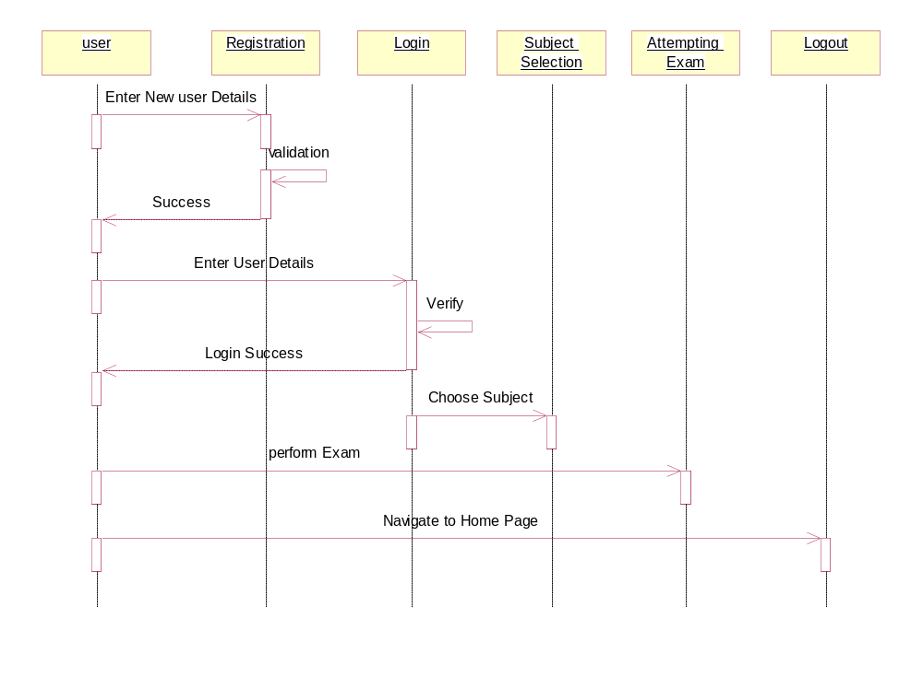

Fig 5.5 Sequence Diagram for User

5.6 Collaboration Diagram

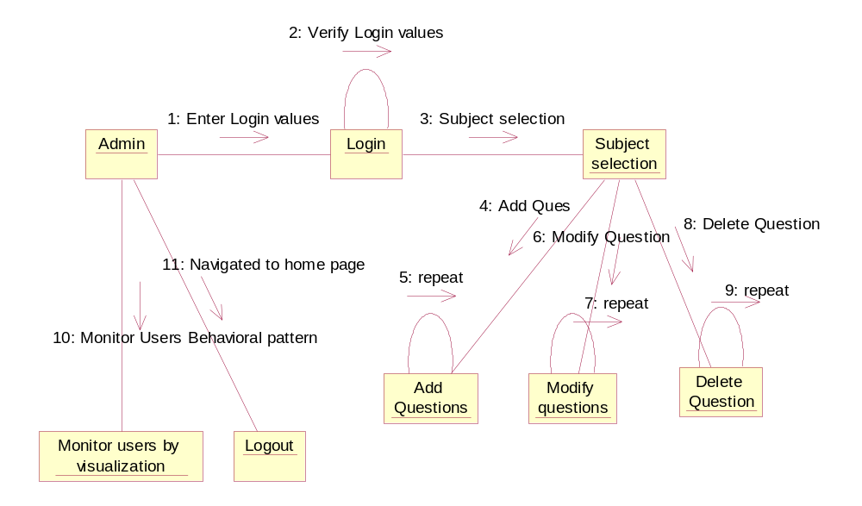

Fig 5.6 Collaboration Diagram for Admin

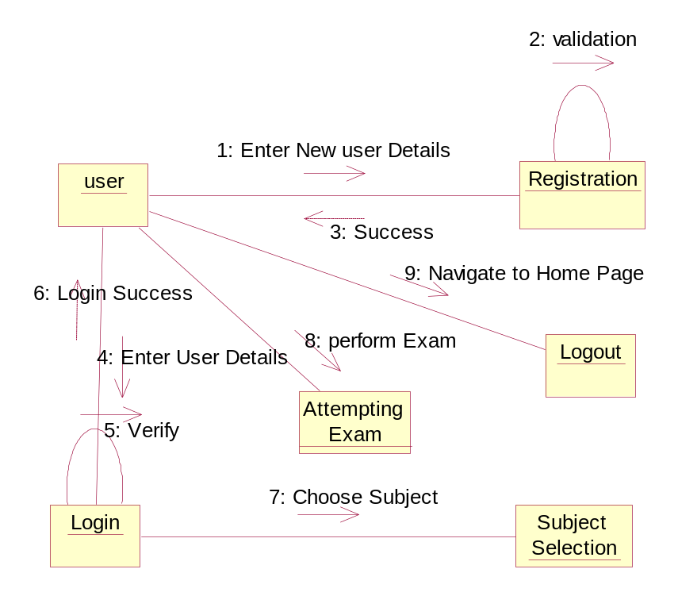

Fig 5.7 Collaboration Diagram for User

Admin
Login
SubjectSelection
AddQues
ModifyQues
DeleteQues
UsersDatavisuvalization
Logout
5.7 State Chart Diagrams

Fig 5.8 State Diagram for Admin

User
Registration
Login
SubjectSelection
AttemptingExam
Logout

Fig 5.9 State Diagram for User

5.8 Component Diagram

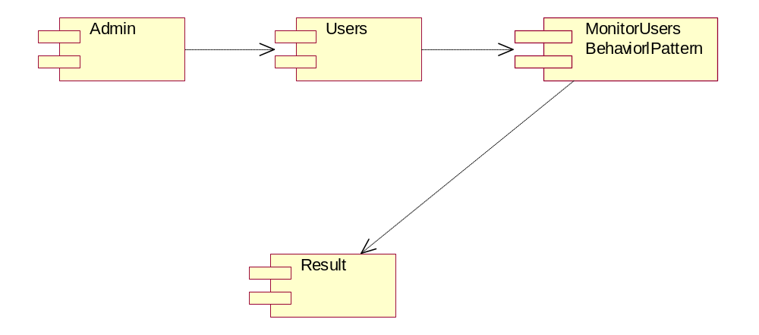

Fig 5.10 Component Diagram for Monitoring Online Tests

6.1 Hardware requirements
Processor PENTIUM IV 3.0 GHZ
RAM 256 MB
Hard Disk 80 GB
Mouse Logitech Serial Mouse
Keyboard Standard 104 Enhanced Keyboard

6.2 Software requirements
Web Server Apache Tomcat Server 5.5
Browser Internet Explorer
Server side scripting JSP
Database mysql5.1
Language Java,j2EE
Client side scripting HTML
Visualization API JFreechart1.0.13

7.1 Code design characteristics
7.1.1 Java Script
JavaScript is a script-based programming language that was developed by Netscape Communication Corporation. JavaScript was originally called Live Script and renamed as JavaScript to indicate its relationship with Java. JavaScript supports the development of both client and server components of Web-based applications. On the client side, it can be used to write programs that are executed by a Web browser within the context of a Web page. On the server side, it can be used to write Web server programs that can process information submitted by a Web browser and then updates the browser’s display accordingly
Even though JavaScript supports both client and server Web programming, we prefer JavaScript at Client side programming since most of the browsers supports it. JavaScript is almost as easy to learn as HTML, and JavaScript statements can be included in HTML documents by enclosing the statements between a pair of scripting tags
<SCRIPTS>..</SCRIPT>.
<SCRIPT LANGUAGE = “JavaScript”>
JavaScript statements
</SCRIPT>
Here are a few things we can do with JavaScript:
- Validate the contents of a form and make calculations.
- Add scrolling or changing messages to the Browser’s status line.
- Animate images or rotate images that change when we move the mouse over them.
- Detect the browser in use and display different content for different browsers.
- Detect installed plug-ins and notify the user if a plug-in is required.

JavaScript Vs Java
JavaScript and Java are entirely different languages. A few of the most glaring differences are: Java applets are generally displayed in a box within the web document; JavaScript can affect any part of the Web document itself.
While JavaScript is best suited to simple applications and adding interactive features to Web pages, Java can be used for incredibly complex applications.
There are many other differences but the important thing to remember is that JavaScript and Java are separate languages. They are both useful for different things; in fact they can be used together to combine their advantages.
Advantages
- JavaScript can be used for Sever-side and Client-side scripting.
- It is more flexible than VBScript. JavaScript is the default scripting languages at Client-side since all the browsers supports it.

7.1.2 Hyper Text Markup Language
Hypertext Markup Language (HTML), the languages of the World Wide Web (WWW), allows users to produces Web pages that include text, graphics and pointer to other Web pages (Hyperlinks).
HTML is not a programming language but it is an application of ISO Standard 8879, SGML (Standard Generalized Markup Language), but specialized to hypertext and adapted to the Web. The idea behind Hypertext is that instead of reading text in rigid linear structure, we can easily jump from one point to another point. We can navigate through the information based on our interest and preference. A markup language is simply a series of elements, each delimited with special characters that define how text or other items enclosed within the elements should be displayed.

Hyperlinks are underlined or emphasized works that load to other documents or some portions of the same document.HTML can be used to display any type of document on the host computer, which can be geographically at a different location. It is a versatile language and can be used on any platform or desktop.
HTML provides tags (special codes) to make the document look attractive. HTML tags are not case-sensitive. Using graphics, fonts, different sizes, color, etc., can enhance the presentation of the document. Anything that is not a tag is part of the document itself.

Advantages
- A HTML document is small and hence easy to send over the net. It is small because it does not include formatted information.
- HTML is platform independent.
- HTML tags are not case-sensitive.

7.1.3 Java Server Pages (JSP)
Java server Pages is a simple, yet powerful technology for creating and maintaining dynamic-content web pages. Based on the Java programming language, Java Server Pages offers proven portability, open standards, and a mature re-usable component model .The Java Server Pages architecture enables the separation of content generation from content presentation. This separation not eases maintenance headaches, it also allows web team members to focus on their areas of expertise. Now, web page designer can concentrate on layout, and web application designers on programming, with minimal concern about impacting each other’s work.

Features of JSP
- Portability
Java Server Pages files can be run on any web server or web-enabled application server that provides support for them. Dubbed the JSP engine, this support involves recognition, translation, and management of the Java Server Page lifecycle and its interaction components.

- Components
It was mentioned earlier that the Java Server Pages architecture can include reusable Java components. The architecture also allows for the embedding of a scripting language directly into the Java Server Pages file. The components current supported include Java Beans, and Servlets.

- Processing
A Java Server Pages file is essentially an HTML document with JSP scripting or tags. The Java Server Pages file has a JSP extension to the server as a Java Server Pages file. Before the page is served, the Java Server Pages syntax is parsed and processed into a Servlet on the server side. The Servlet that is generated outputs real content in straight HTML for responding to the client.

Steps in the execution of a JSP Application
The client sends a request to the web server for a JSP file by giving the name of the JSP file within the form tag of a HTML page. This request is transferred to the Java Web Server. At the server side Java Web Server receives the request and if it is a request for a JSP file server gives this request to the JSP engine. JSP engine is program which can understand the tags of the JSP and then it converts those tags into a Servlet program and it is stored at the server side.
This Servlet is loaded in the memory and then it is executed and the result is given back to the Java Web Server and then it is transferred back to the result is given back to the Java Web Server and then it is transferred back to the client.

7.1.4 JDBC connectivity
The JDBC provides database-independent connectivity between the J2EE platform and a wide range of tabular data sources. JDBC technology allows an Application Component Provider to:
- Perform connection and authentication to a database server
- Manages transactions
- Move SQL statements to a database engine for preprocessing and execution
- Execute stored procedures
- Inspect and modify the results from Select statements
The generated application is the first version upon the system. The overall system is planned to be in the formal of distributed architecture with homogeneous database platform. The major objective of the overall system is to keep the following components intact.
- System consistency.
- System integrity.
- Overall security of data.
- Data reliability and Accuracy
- User friendly name both at administration and user levels.
- Considering the fact of generality and clarity.

7.2 Stored Procedures (PL/SQL)

FIELDS | CONSTRAINT | DATA TYPE
USER | PRIMARY KEY | VARCHAR2(20)
PASSWORD | NOT NULL | VARCHAR2(20)
AUTH | NOT NULL | VARCHAR2(10)

TABLE 7.1 LOGIN

FIELDS | CONSTRAINT | DATA TYPE
FIRSTNAME | NOT NULL | VARCHAR2(20)
LASTNAME | NOT NULL | VARCHAR2 (20)
EMAIL | NOT NULL | VARCHAR2 (20)
PHONE | NOT NULL | VARCHAR2 (20)
GENDER | NOT NULL | VARCHAR2 (5)
QUALIFICATION | NOT NULL | VARCHAR2 (50)
SKILLS | NOT NULL | VARCHAR2 (20)
EXPERIENCE | NOT NULL | VARCHAR2 (20)
ADDRESS | NOT NULL | VARCHAR2 (50)

TABLE 7.2 REGISTER

FIELDS | CONSTRAINT | DATA TYPE
SUBJECT | PRIMARY KEY | VARCHAR2(50)
QNO | PRIMARY KEY | NUMBER(10)
QUESTION | NOT NULL | VARCHAR2 (500)
ANS1 | NOT NULL | VARCHAR2 (500)
ANS2 | NOT NULL | VARCHAR2 (500)
ANS3 | NOT NULL | VARCHAR2 (500)
ANS4 | NOT NULL | VARCHAR2 (500)
ANS | NOT NULL | VARCHAR2 (500)
LEVEL | PRIMARY KEY | NUMBER(10)

TABLE 7.3 QUESTIONS

FIELDS | CONSTRAINT | DATA TYPE
EMAIL ID | NOT NULL | VARCHAR2(50)
QNO | NOT NULL | NUMBER(10)
SUBJECT | NOT NULL | VARCHAR2 (30)
QUESTION | NOT NULL | VARCHAR2 (500)
ANSWER | NOT NULL | VARCHAR2 (500)
CORRECT ANSWER | NOT NULL | VARCHAR2 (500)
MARKS | NOT NULL | NUMBER (5)
LEVEL | NOT NULL | NUMBER (5)
TIME | NOT NULL | NUMBER (3)
NOP | NOT NULL | NUMBER (3)
TABLE 7.4 RESULT
7.3 Coding
register.jsp
<%@ page errorPage="errorpge.jsp" %>
<%@ page language="java" import="java.sql.*" %>
<body bgcolor="#AAAAAA">
<%
String first=request.getParameter("fname");
String last=request.getParameter("lname");
String email=request.getParameter("eid");
String contact=request.getParameter("conno");
String gen=request.getParameter("gender");
String address=request.getParameter("address");
String auth="1";
try{
Class.forName("sun.jdbc.odbc.JdbcOdbcDriver");
Connection con=DriverManager.getConnection("jdbc:odbc:etest","etest","etest");
Statement stmt=con.createStatement();
int rowsAffected=stmt.executeUpdate("insert
intoregister(firstname,lastname,email,phone,gender,qual,skills,exp,address) values ('"+first+"','"+last+"','"+email+"','"+contact+"','"+gen+"','"+qual+"','"+skill+"','"+exper+"','"+address+"')");
if(rowsAffected ==1){
session.setAttribute("user",email);
Statement stmt1=con.createStatement();
int rowsAffected1=stmt1.executeUpdate("insert into login(user1,password,auth) values ('"+email+"','"+first+"','" +auth+"')");
%>

test.jsp
var nop=0;
var ttaken=0;
function selectAnswer()
{
nop++;
// alert(parseInt(nop));
document.form1.nop.value=nop;
}
function getTime()
{
ttaken=15-time1;
// alert(parseInt(ttaken));
document.form1.ttaken.value=ttaken;
}
var time1;
time1=15;
function DisplayTime()
{
if (time1==0 )
{
document.form1.submit();
return true;
}
time1=time1-1;
if (time1<=5)
{
document.form1.textfield.value = time1 + " Seconds Only" ;
}
window.status="Time Left: " + time1;
window.setTimeout("DisplayTime()",1000);
return true;
}
DisplayTime();
<%@ page errorPage="errorpge.jsp" %>
<%@ page language="java" import="java.sql.*" %>
<% String us=(String)session.getAttribute("user1");
session.setAttribute("user11",us);%>
<%String subj=request.getParameter("exam");
System.out.println("The Exam is:"+subj);
session.setAttribute("subjj",subj);%>
<%= subj %>
<%
try{
int qn=1;
if(qn>=11) {
response.sendRedirect("ViewResults.jsp");
}

MultiUserGraph.jsp
<%@ page import="java.sql.*" %>
<%@ page import="java.io.*" %>
<%@ page import="org.jfree.chart.ChartFactory" %>
<%@ page import="org.jfree.chart.ChartUtilities" %>
<%@ page import="org.jfree.chart.JFreeChart" %>
<%@ page import="org.jfree.chart.plot.PlotOrientation"%>
<%@ page import="org.jfree.data.*" %>
<%@ page import="org.jfree.data.jdbc.JDBCCategoryDataset"%>
<%
Class.forName("sun.jdbc.odbc.JdbcOdbcDriver");
Connection con = DriverManager.getConnection("jdbc:odbc:etest","etest","etest");
Statement stmt = con.createStatement();
//data = new JdbcCategoryDataset(con);
//session.setAttribute("graphuser",request.getParameter("user11"));
String query="select emailid,sum(time) from result group by emailid";
JDBCCategoryDataset dataset=new JDBCCategoryDataset(con);
dataset.executeQuery( query);
JFreeChart chart = ChartFactory .createBarChart3D("Multi Graph of Time Lines","Users","TotalTime",dataset, PlotOrientation.VERTICAL,true, true,false);
try
{
ChartUtilities.saveChartAsJPEG(new File("E:\\mtechdatavisuvalization\\javadm02finalcode\\datavizuvalfinal\\web\\images\\Multigraph1.jpg"), chart, 400, 300);
}
catch (IOException e)
{
System.out.println("Problem in creating chart.");}%>
<html>
<head>
<meta http-equiv="Content-Type" content="text/html; charset=UTF-8">
<title>display graph</title>
</head>
<body bgcolor="gray">

<!--<table>
<tr><td><a href="OptionsGraph.jsp">OptionsGraph</td><td><a href="MultiUserGraph.jsp">MultiUserGraph</td></tr>
</table>-->

8 Software Testing

Software testing is a critical element of software quality assurance and represents the ultimate review of specification, design and coding. The user tests the developed system and changes are made according to their needs. Testing is a process, which reveals errors in the program. It is the major quality measure employed during software development. During testing, the program is executed with a set of test cases and the output of the program for the test cases is evaluated to determine if the program is performing as it is expected to perform.
When a system is developed, it is hoped that it performs properly. In practice however some errors always occur. The main purpose of testing an information system is to find the errors and correct them. A successful test is one that found an error. The main objectives of the system testing are,

- To ensure during operation the system will perform as per specification.
- To make sure that the system meets user requirements during operation.
- To verify that the controls incorporated in the system function as intended.
- To see that when correct inputs are fed to the system and the outputs are correct.
- To make sure that during operation, incorrect input processing and output will be deleted.

If the testing is conducted successfully, it will uncover errors in the software. As a secondary benefit, testing demonstrates that the software functions appear to be working according to specification and that performance requirements appear to have been made.

8.1 Testing Strategies
In order to make sure that the system does not have errors, the different levels of testing strategies that are applied at differing phases of software development are:

8.1.1 Unit Testing
This is the first level of testing that was done. In this, different modules were tested against the specifications produced during the design of modules. Unit testing was done for verification of the code produced during the coding phase and to test the internal logic of modules. It refers to the verification of the single program module in an isolated environment. Unit testing focused on the modules, independent of one another, to locate errors those resulting from the interaction between the modules were initially avoided. After coding, each dialog was tested and run individually. All unnecessarily coded statements were removed and it was ensured that all the functionality worked as expected. Logical errors found were corrected. Unit Testing is done on individual modules as they are completed and become executable. It is confined only to the designer's requirements.

8.1.2 Black Box Testing
In this strategy some test cases are generated as input conditions that fully execute all functional requirements for the program. In this testing only the output is checked for correctness. The logical flow of the data is not checked. This testing has been uses to find errors in the following categories:
- Incorrect or missing functions
- Interface errors
- Errors in data structure or external database access
- Performance errors
- Initialization and termination errors

8.1.3 White Box Testing
In this the test cases are generated on the logic of each module by drawing flow graphs of that module and logical decisions are tested on all the cases. It has been uses to generate the test cases in the following cases:
- Guarantee that all independent paths have been executed.
- Execute all logical decisions on their true and false Sides.
- Execute all loops at their boundaries and within their operational bounds.
- Execute internal data structures to ensure their validity.

8.1.4 Integration Testing
The main advantage of integration testing is that it recovers all the hidden errors. Validation of project mainly based on the correctness of entropy algorithm in fast fractal. So the integration testing is mainly checking the correctness of entropy algorithm.
8.1.5 Validation Testing
The system as a whole was deployed in the JAVA 1.5 and was tested. The system was found to be working perfect and an end user has been asked to enter the data, and validated.

8.2 Test Cases
Test case 1: Unit testing in login form.
Test Objective: Validating the login form.
Description: In this form the Tutor enters the username and password. If the username and password are correct then the login is successful and tutor enter into his corresponding page else error message “invalid username and password, try again” appears.
Test Environment: Java/ ORACLE
Action: User enters the correct username and password.
Result: Login Successful

Test Case 2: Unit testing in Add Questions form.
Test Objective: To validate the constraints imposed.
Description: In this form we enter the Question no, answer a, answer b, answer c, answer d, correct answer and level of questions. All these fields are compulsory. If these compulsory fields are not entered then the dialog box “All fields are mandatory” appears.
Test Environment: Java/ ORACLE.
Action: User doesn’t enter all the fields.
Result: Questions are not added.

Test case 3: Integration Testing
Test Objective: Checking the connectivity of all the forms.
Description: Connecting all the forms and verifying its functionality.
Test Environment: Java
Action: All forms are connected properly

Result: Project Executed successfully.

Test case 4: Black box testing for admin’s change password form.
Test Objective: To validate the constraints imposed.
Description: In this form when admin tries to change the password without providing the confirm password, the password cannot be changed with an error “Invalid password”.
Test Environment: Java/ ORACLE
Action: User doesn’t enter the confirm password.
Result: Password is not changed.

Test case 5: White box testing for User’s select subject form to start e-test.
Test Objective: To check the Database information.
Description: In this form when user select selects a subject to start e-test, error is displayed if the selected subject questions are not found in database.
Test Environment: Java/ ORACLE
Action: Questions are entered in the database.
Result: The e-test is started successfully.

9. Output Screens

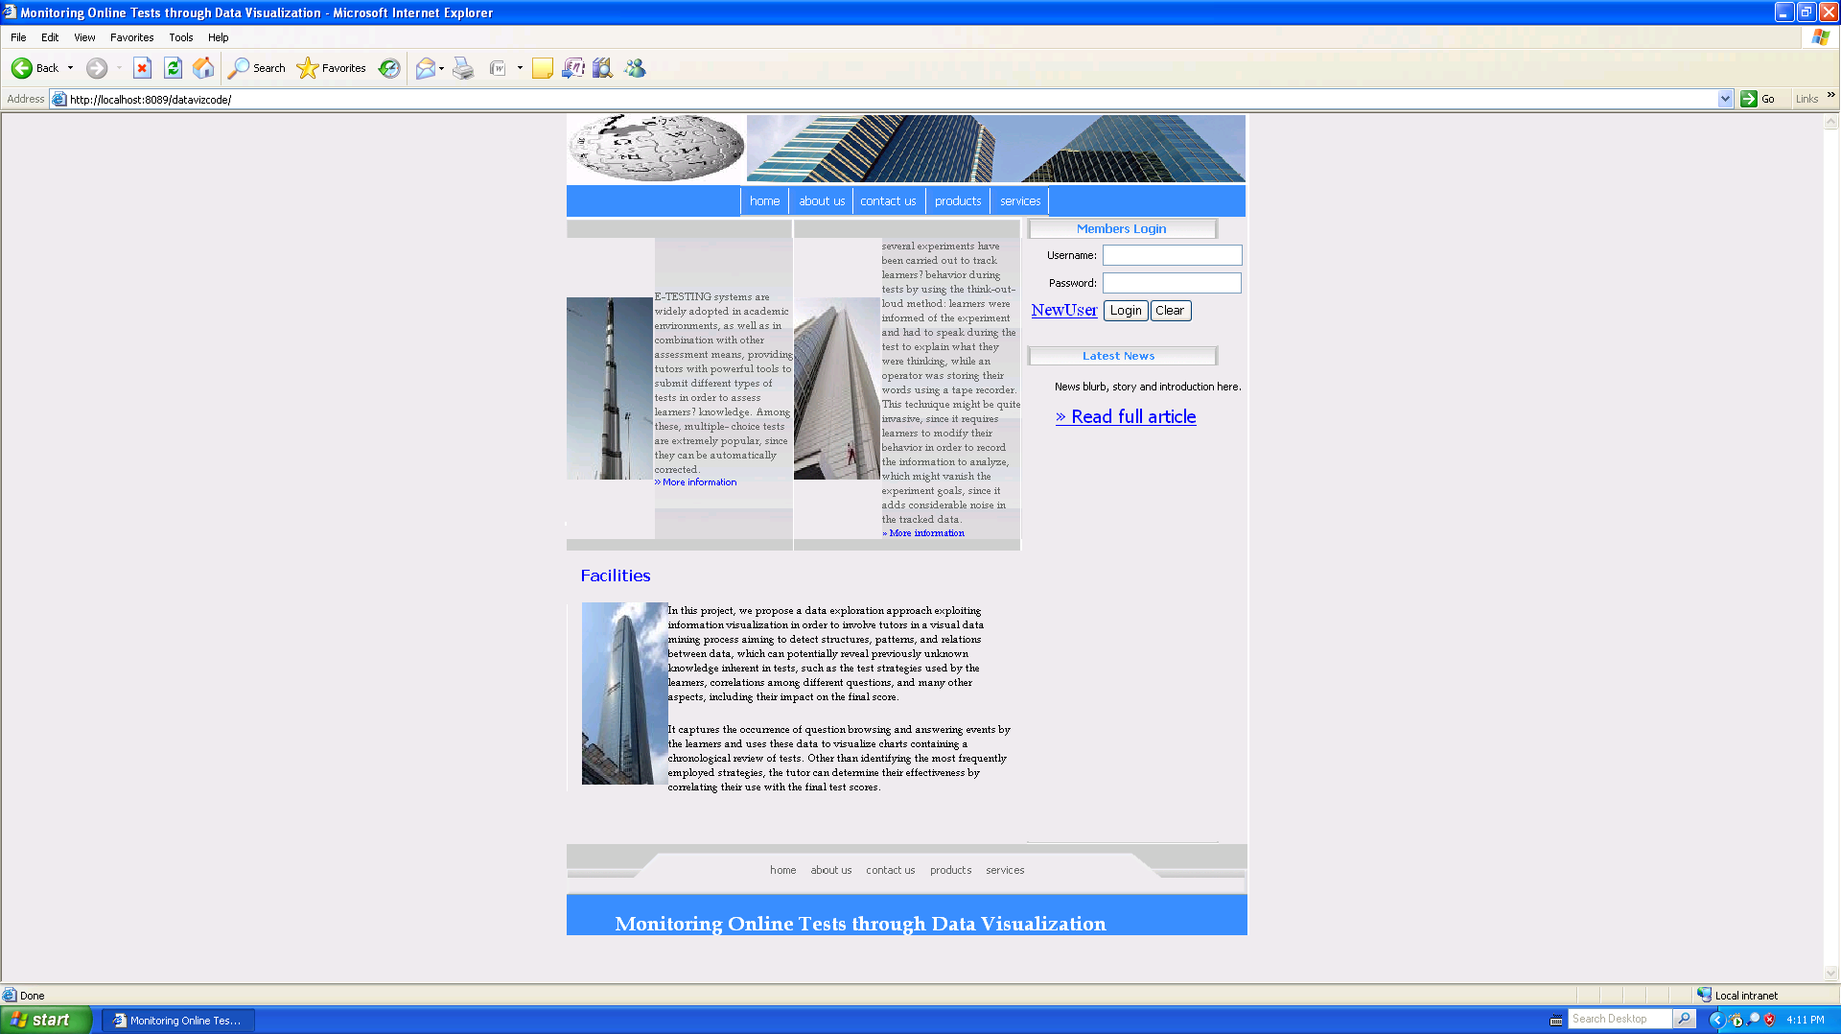

Screen 9.1 Login Form

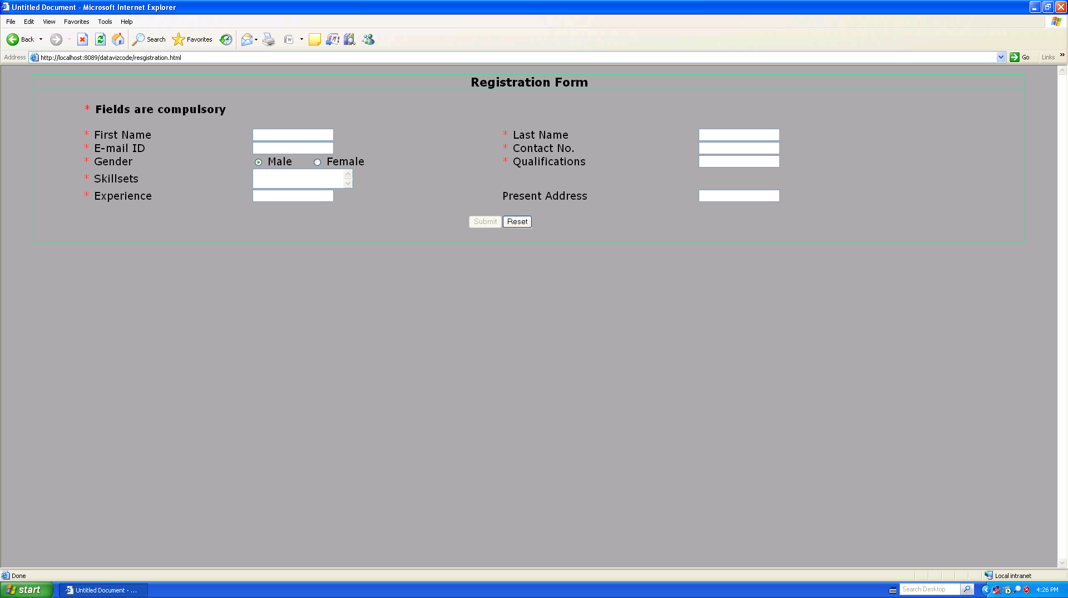

Screen 9.2 Registration form of User

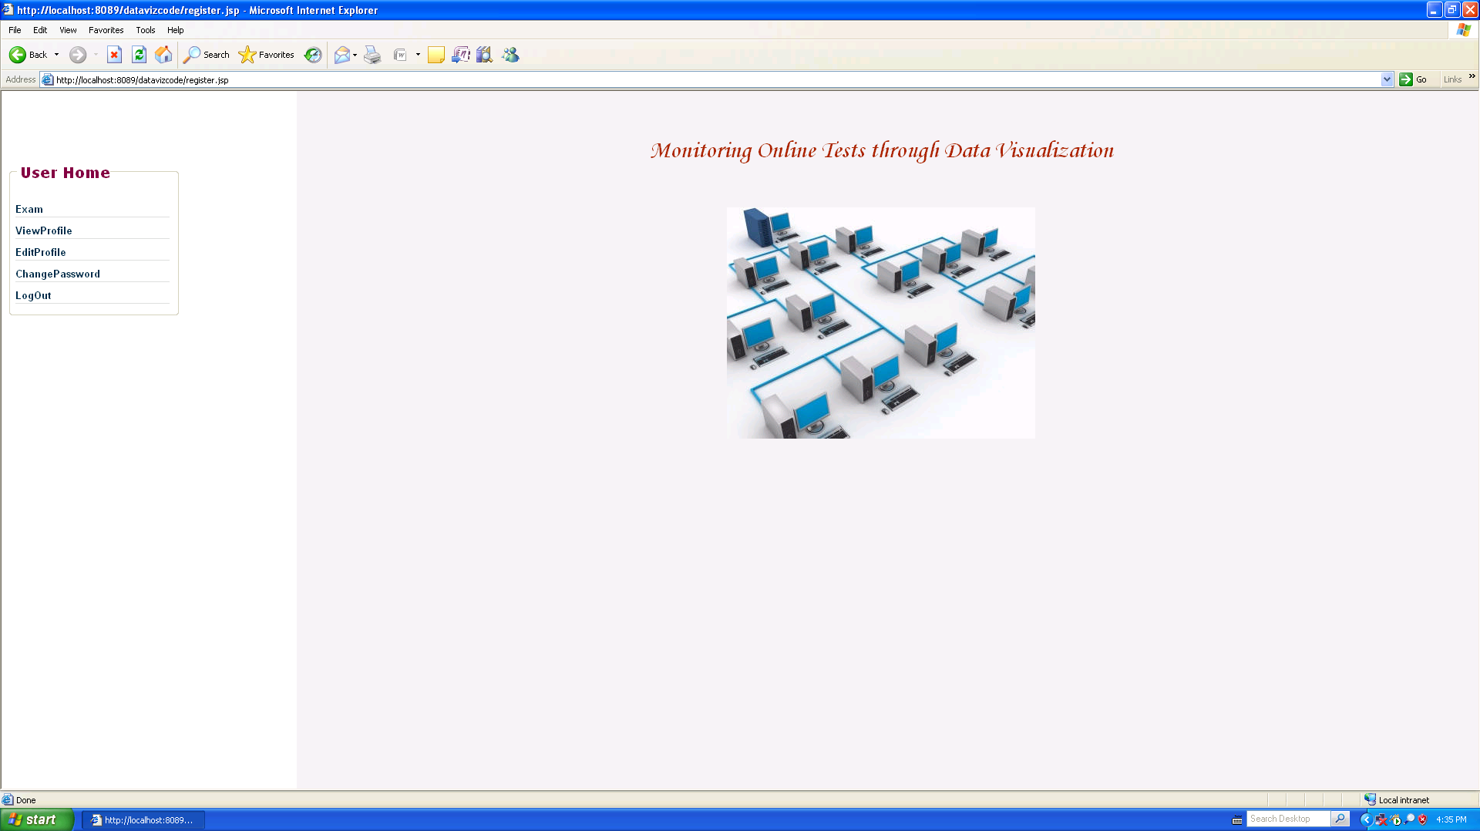

Screen 9.3 User Home Page

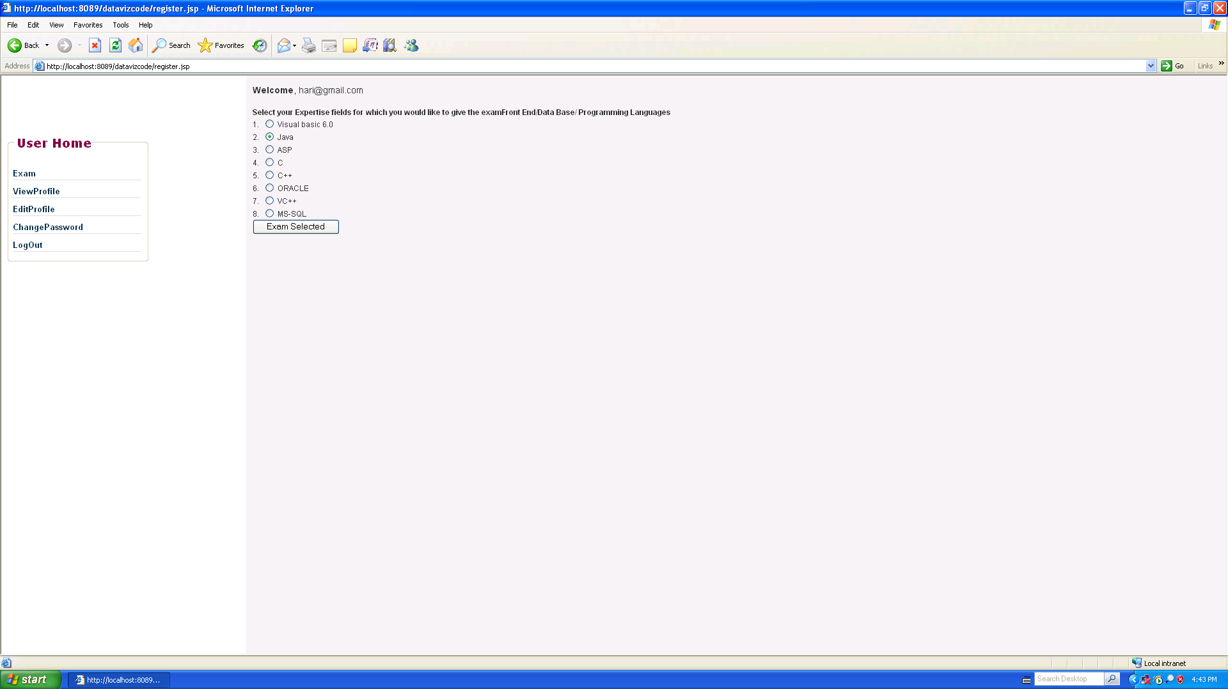

Screen 9.4 Subject selection form of user

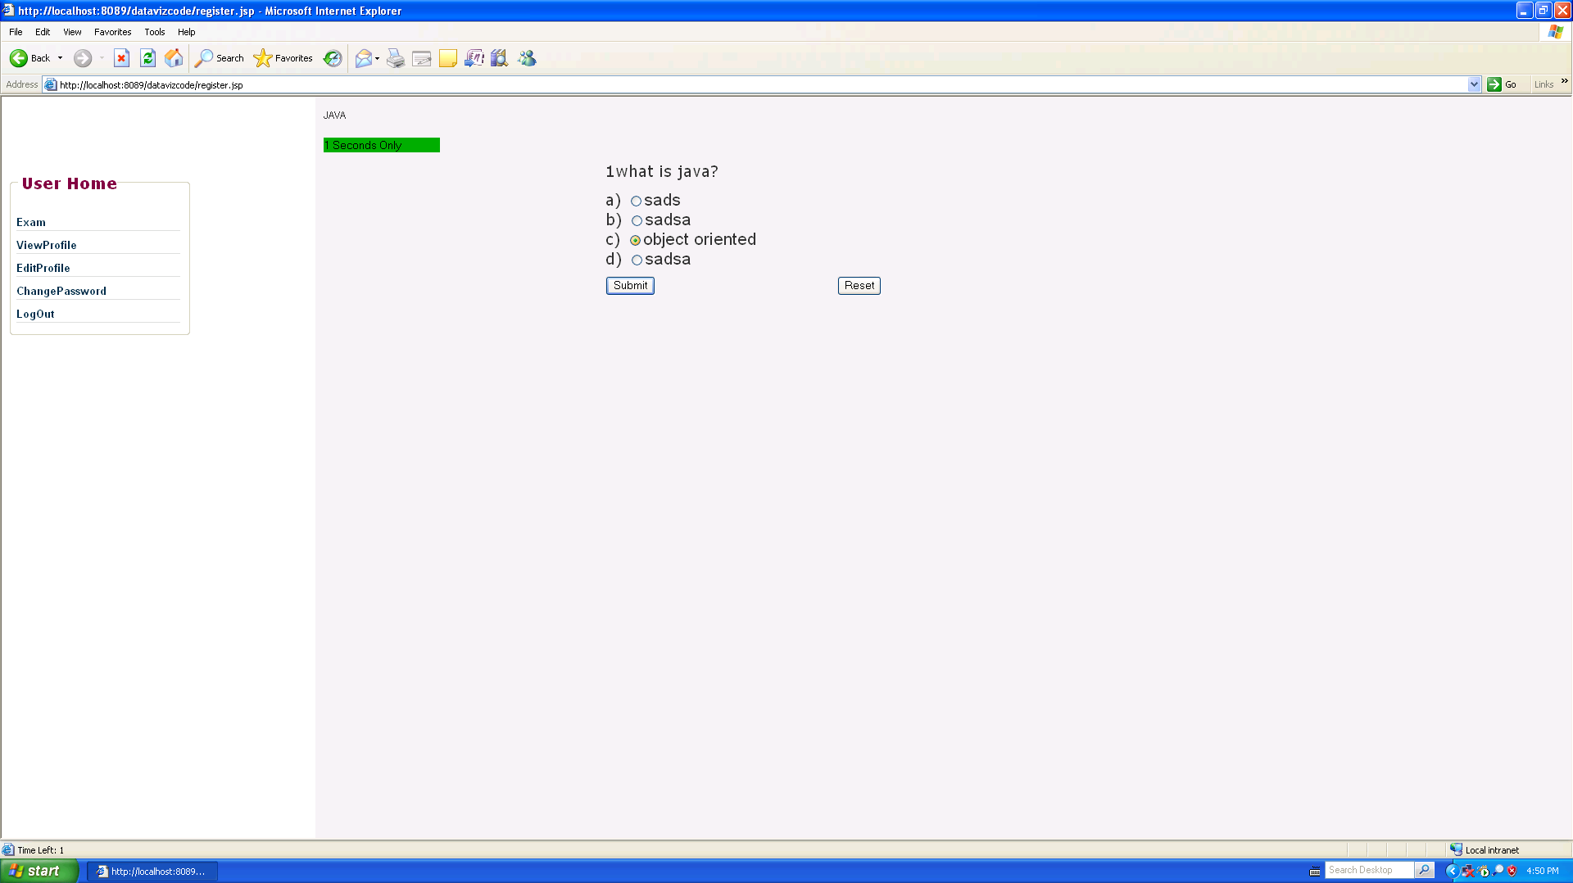

Screen 9.5 Online Exam performed by user

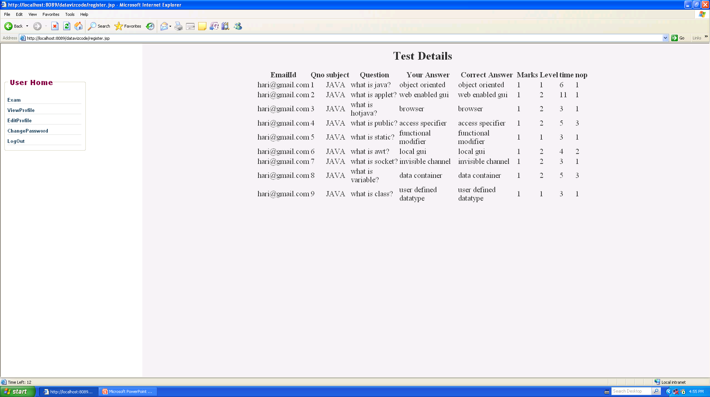

Screen 9.6 Test Details of user performed the test

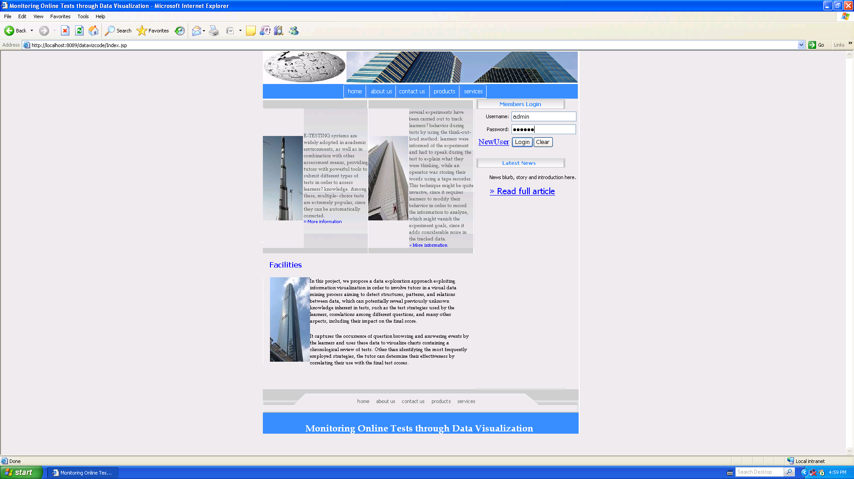

Screen 9.7 Login form of Admin

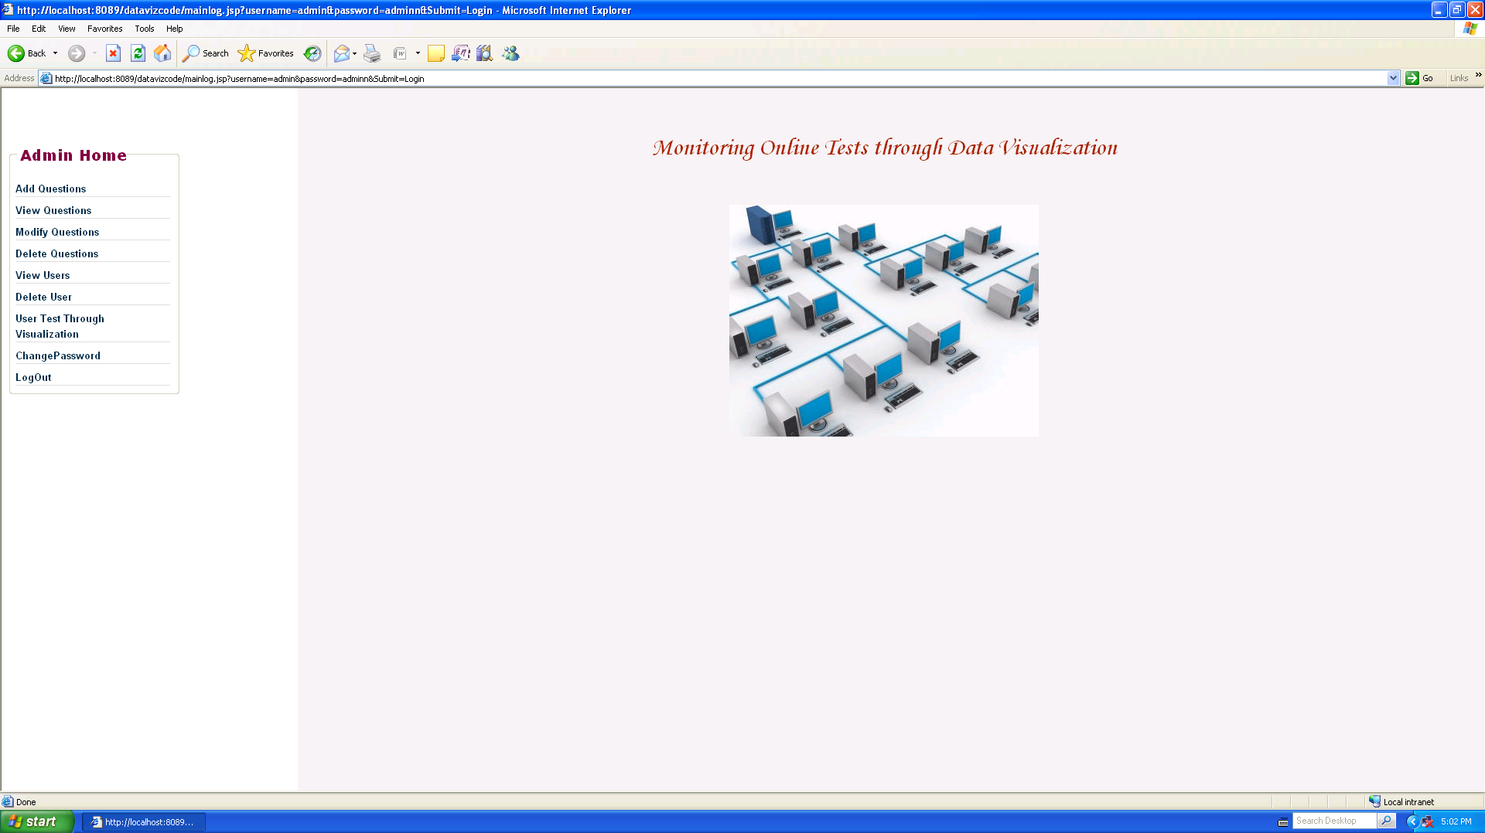

Screen 9.8 Home page of Admin

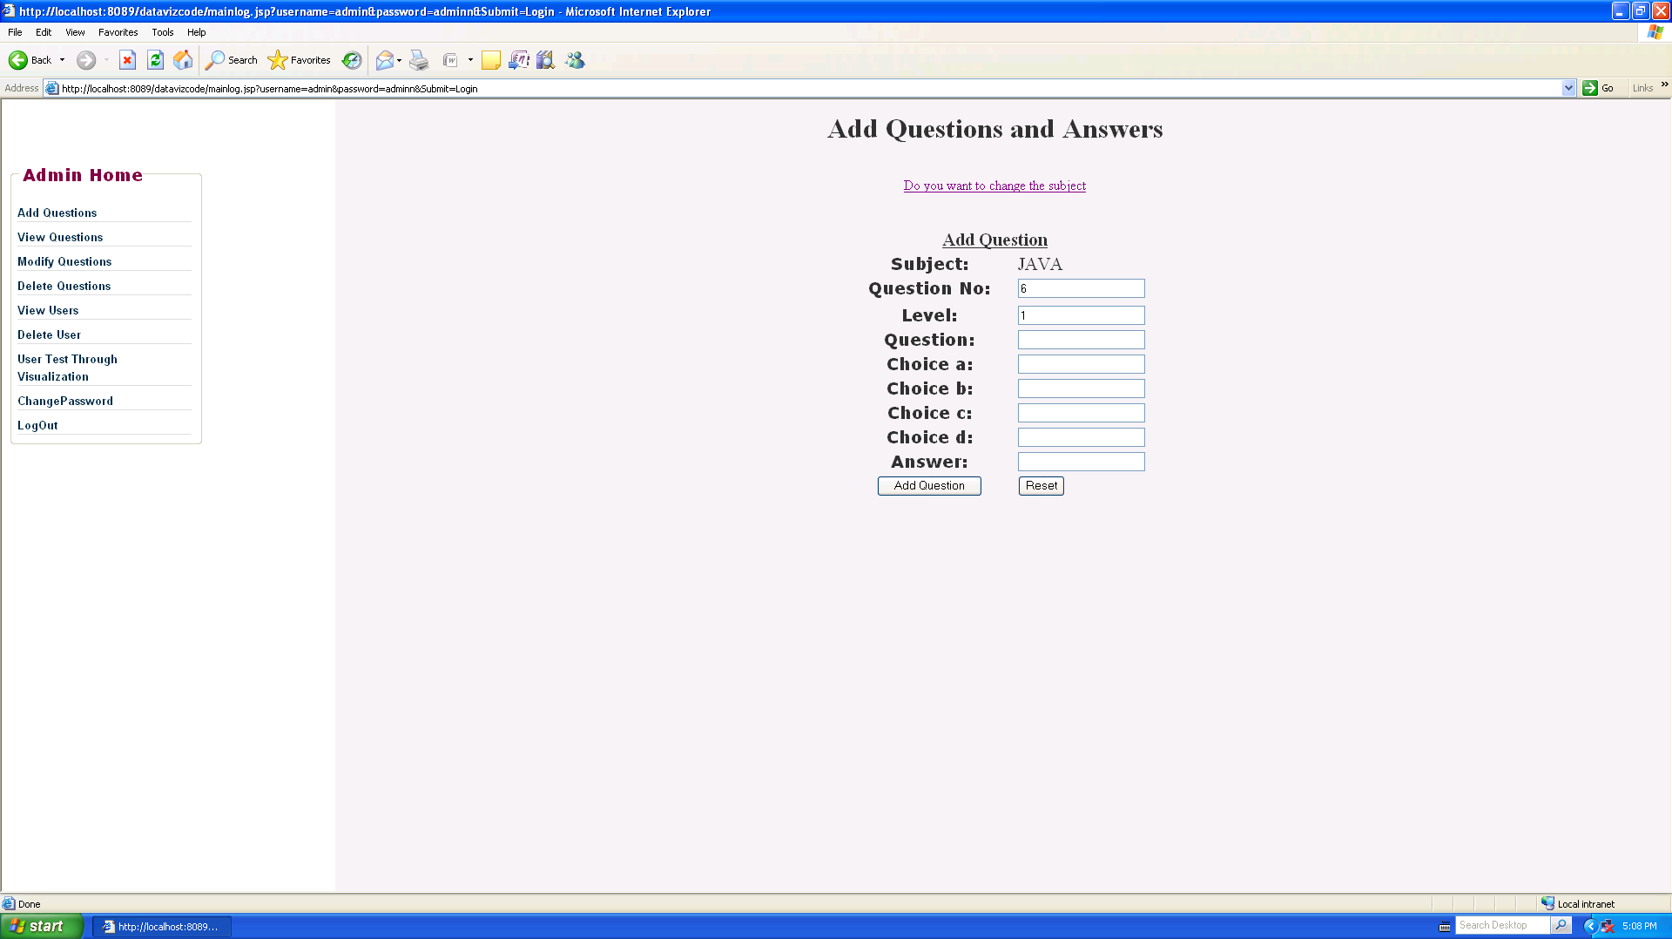

Screen 9.9 Add Questions form of Admin

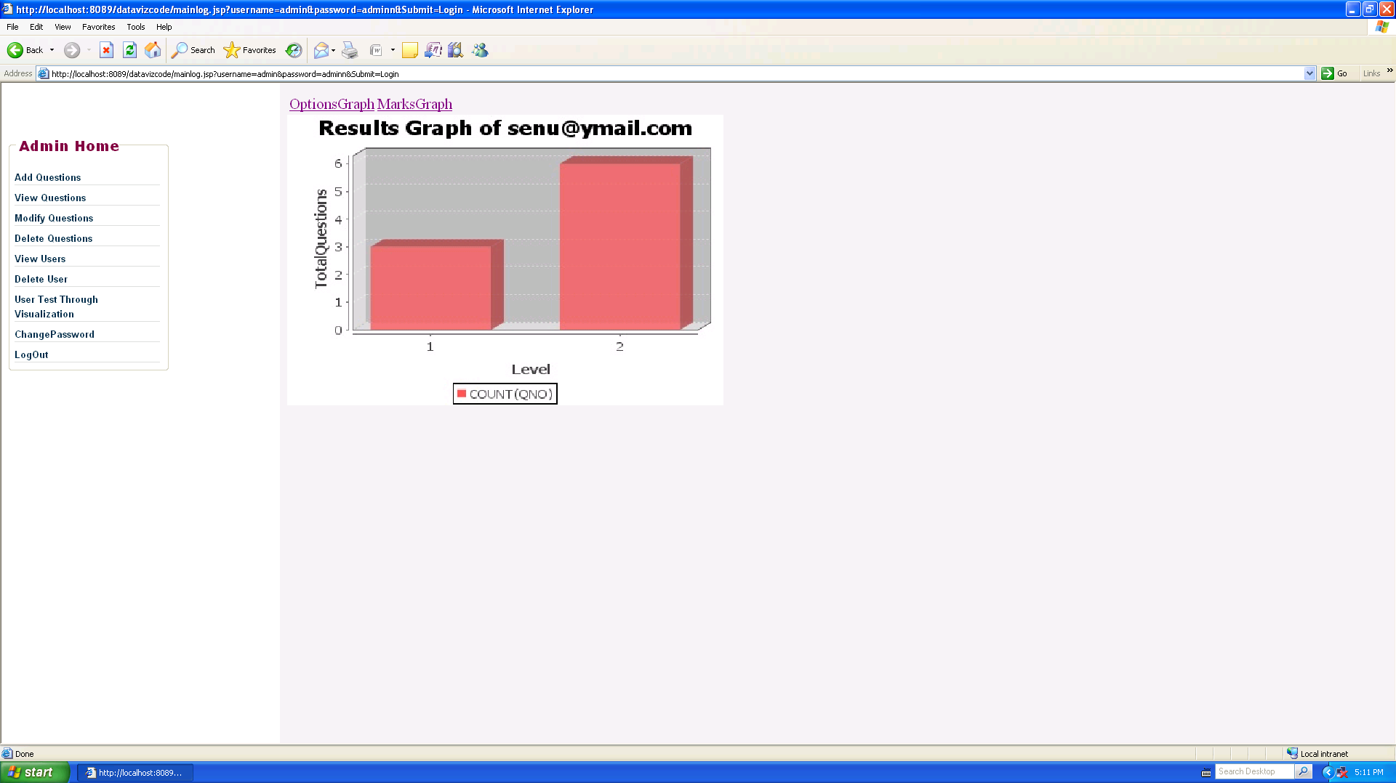

Screen 9.10 Graph for Level of Questions answered by user

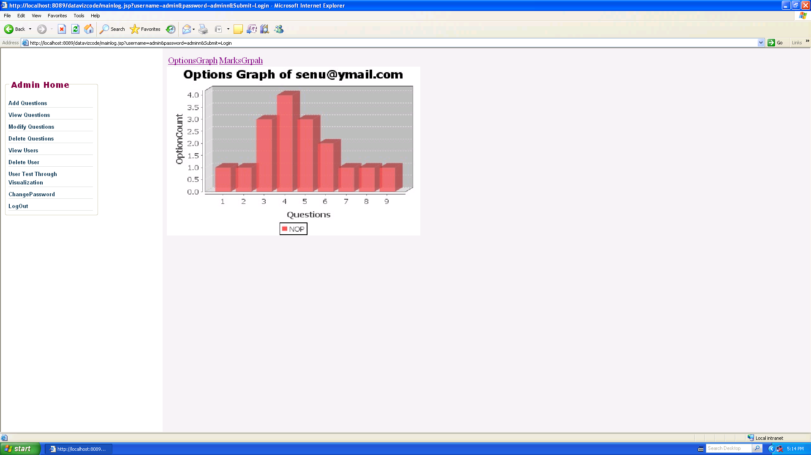

Screen 9.11 Graph for Number of options changed by user

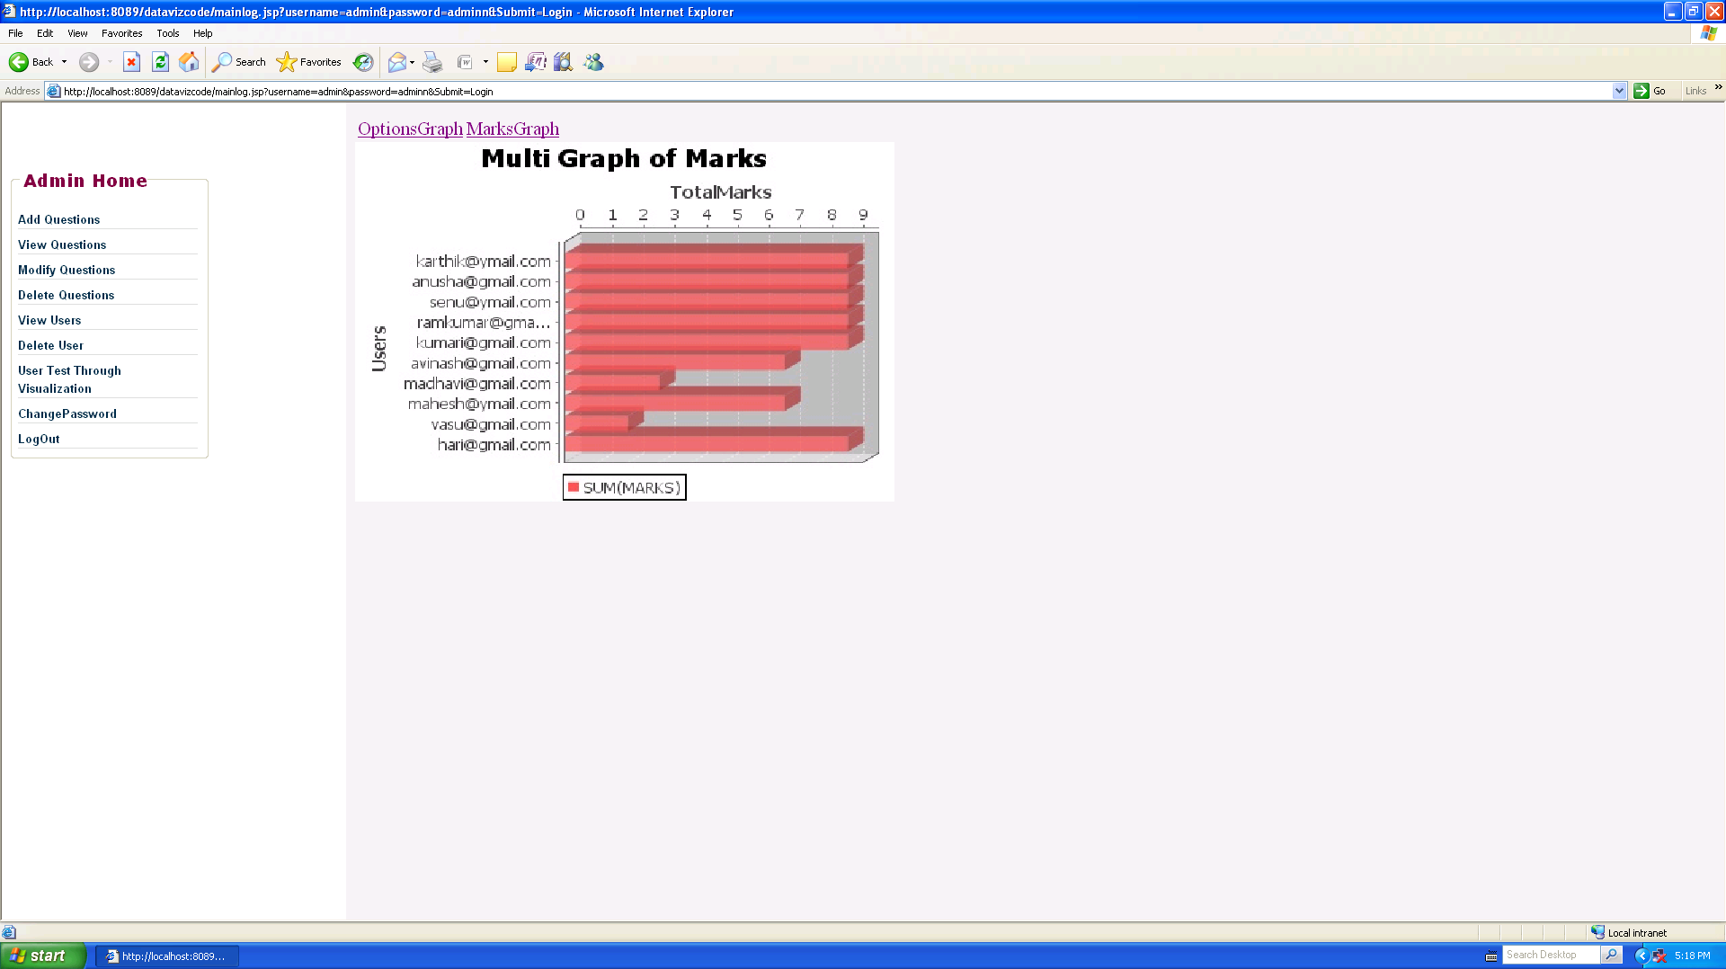

Screen 9.12 Graph for Total Marks Of Multiple Users

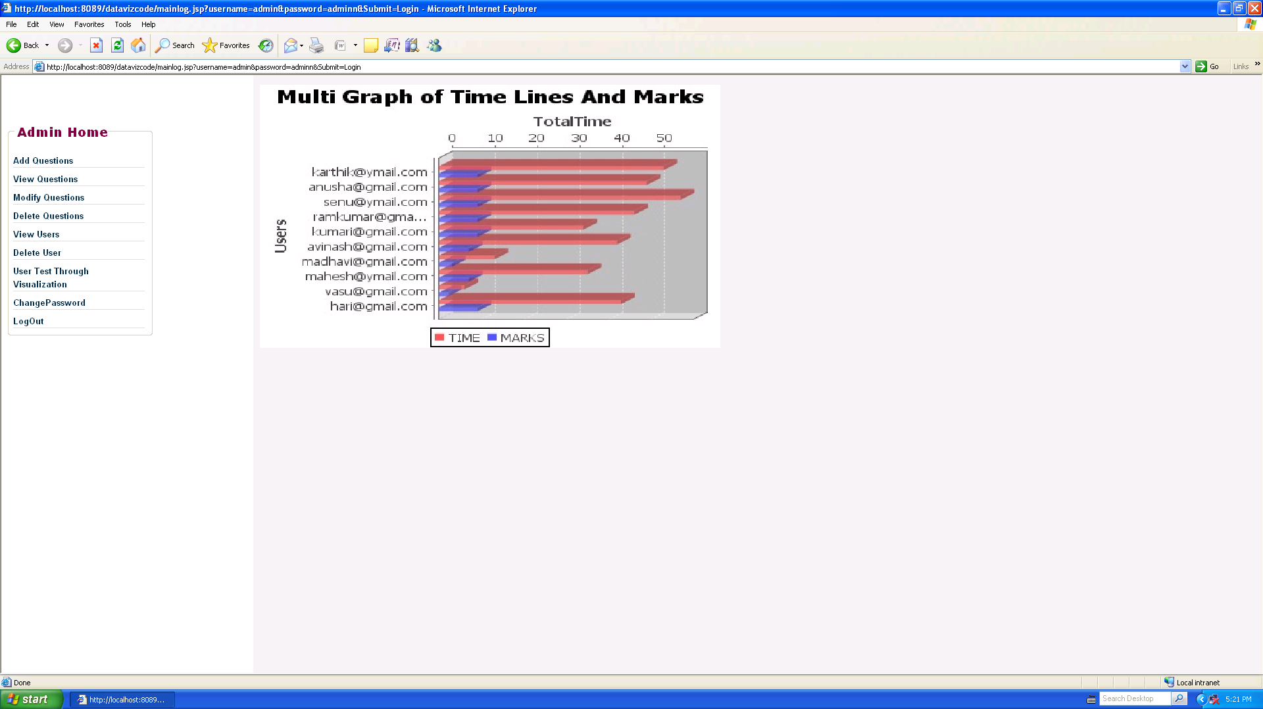

Screen 9.13 Graph for Total Time & Marks taken by Multiple Users

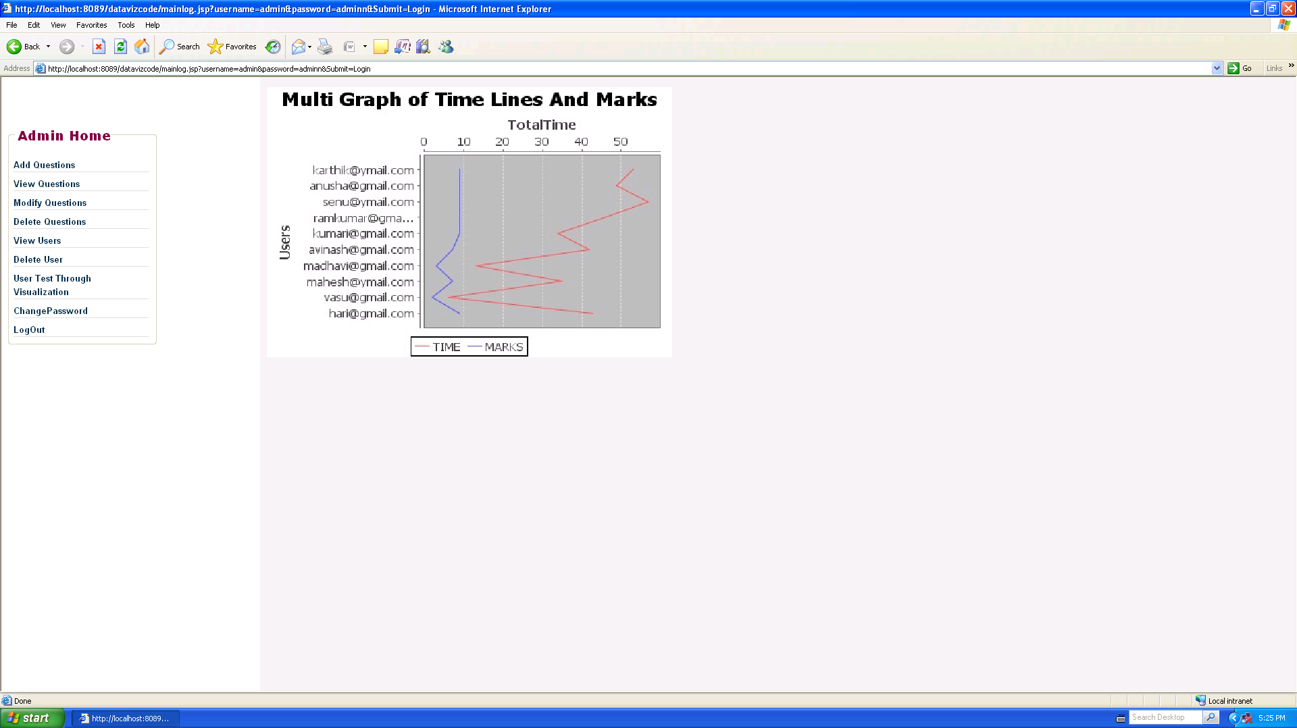

Screen 9.14 Multi Graph of Time lines & Marks

10. Conclusion
This project presents an approach to let tutors monitor learners’ strategies during online tests. The approach exploits data visualization to draw the data characterizing the learner’s test strategy, in order to trigger the tutor’s attention and to let him/her discover previously unknown behavioral patterns of the learners and conceptual relationships among test items.The time taken for each question, level of questions answered, options changed for each question and the total time taken for answering the test are the behavioral patterns taken into consideration in this project. In this way, the tutor is provided with a powerful tool that let him/her review the whole process and evaluate in possible improvements.

11. Future Enhancements
The Test can be conducted to the whole class at a time. The other behaviors of the user can also be monitored. The test can be used for other environment such as aptitude test in interviews, Stress analysis test etc. The project can be enhanced to devise new visual representations and perform further experiments, possibly in combination with classical data mining algorithms. Monitoring Online Tests through Data Visualization is used in academic environments, as well as in combination with other assessment means, providing tutors with powerful tools to submit different types of tests in order to assess learners’ knowledge.

12. References

- G. Grinstein and M. Ward, “Introduction to Data Visualization,” Information Visualisation in Data Mining and Knowledge Discovery, Morgan Kaufmann, 2002.
- D.A. Keim, “Information Visualization and Visual Data Mining,”IEEE Trans. Visualization and Computer Graphics, vol. 8, Jan.-Mar. 2002.
3. J. Bath, “Answer-Changing Behaviour on Objective Examinations,”
J. Educational Research, no. 61,1967.
- Herbert Schildt , JAVA 2 Complete Reference (5th Edition).
5. Avi Silberschatz Henry F. Korth S. Sudarshan, Database System Concepts, by
Tata McGraw-Hill Publications.
6. Roger S.Pressman, Software Engineering- A Practitioner's Approach, Sixth Edition,
Tata McGraw-Hill.
- Dietel and Dietel, 3rd edition,” internet and world wide web”.
8. C. Plaisant and B. Shneiderman, “Show Me! Guidelines forProducing Recorded

Demonstrations,”.
9. R. Mazza and V. Dimitrova, “Student Tracking and Personalization:
Visualising Student Tracking Data to Support Instructors in
Web-Based Distance Education,”

10. R.S. Baker, A.T. Corbett, K.R. Koedinger, and A.Z. Wagner, “Off-
Task Behavior in the Cognitive Tutor Classroom: When Students
‘Game the System’,”

11. Asynchronous JavaScript Technology and XML (Ajax) with the Java
Platform, http://java.sun.com/developer/technicalArticles/
J2EE/AJAX/, 2007.

12. G. Costagliola, F. Ferrucci, V. Fuccella, and F. Gioviale, “A Web
Based Tool for Assessment and Self-Assessment,”

13. U. Dem_sar, “Data Mining of Geospatial Data: Combining Visual
and Automatic Methods,”.

14. U. Fayyad and G. Grinstein, “Introduction,” Information Visualisation
in Data Mining and Knowledge Discovery, Morgan Kaufmann,
2002.

15. D.A. Keim and M. Ward, “Visualization,” Intelligent Data Analysis,
M. Berthold and D.J. Hand, eds., second ed. Springer, 2003.

16. D.A. Keim, Visual Exploration of Large Data Sets, second ed.
Springer, 2003..

17. G. Grinstein and M. Ward, “Introduction to Data Visualization,”
Information Visualisation in Data Mining and Knowledge Discovery,
Morgan Kaufmann, 2002.

18. P.E. Hoffman and G.G. Grinstein, “A Survey of Visualizations for
High-Dimensional Data Mining,” Information Visualization in Data
Mining and Knowledge Discovery, pp. 47-82, 2002.

19. M. Ankerst, “Visual Data Mining,” PhD dissertation, Ludwig
Maximilians Universitat, Munchen, Germany, 2000.

20. D.A. Keim, W. Mu¨ ller, and H. Schumann, “Visual Data Mining,”
STAR Proc. Eurographics ’02, D. Fellner and R. Scopigno, eds..

